aTouchAway™
by Aetonix

Ontario hospital simplifying chronic COPD management
Lennox and Addington County General Hospital reported a 30-day COPD readmissions reduction from 23% to 3.4%

Image © 2017 Canadian Lung Association. All Rights Reserved.

Empowering and engaging patients in managing their chronic conditions is reducing costs and preventing emergency visits

Chronic diseases like chronic obstructive pulmonary disease (COPD) are placing a growing strain on our healthcare systems and are a common cause of unnecessary hospitalizations.
COPD is a chronic and progressive lung disease that includes bronchitis and emphysema, and is characterized by debilitating breathlessness. It is
primarily caused by smoking. Of all chronic diseases, COPD is the number one reason for hospitalizations in Canada, accounting for the largest number of return visits to emergency departments as well as the highest volume of readmissions.

Dr. Graeme Rocker - a Professor of Medicine at Dalhousie University, developed INSPIRED
(Implementing a Novel and Supportive Program of Individualized care for patients and families Living with Respiratory Disease), a holistic, proactive, hospital-to-home form of COPD care. By providing specialized supports to patients and families
living with late-stage COPD, Dr. Rocker set out to show that individualized services including self- management education, customized action plans, psychosocial / spiritual support, and advance care planning would create significant efficiencies and cost savings, but would also provide patients with better outcomes.
“



aetonix.com
“
“In 2016 the Canadian Foundation for
Healthcare Improvement published results from a 10 province deployment
of the INSPIRED program that showed
hospitalizations due to COPD could be
decreased by up to 80% by supporting patients in their homes. This approach wouldn’t just improve the quality of care, but would also avoid 68,500 potential emergency department visits, 44,100 hospitalizations and 400,000 bed
days - saving $688 million in
hospital costs over five years.”
The Canadian Foundation for Healthcare Improvement
is a not-for-profit organization funded by Health Canada. www.cfhi-fcass.ca

COPD Patient Outreach Program
2

aTouchAway™
by Aetonix

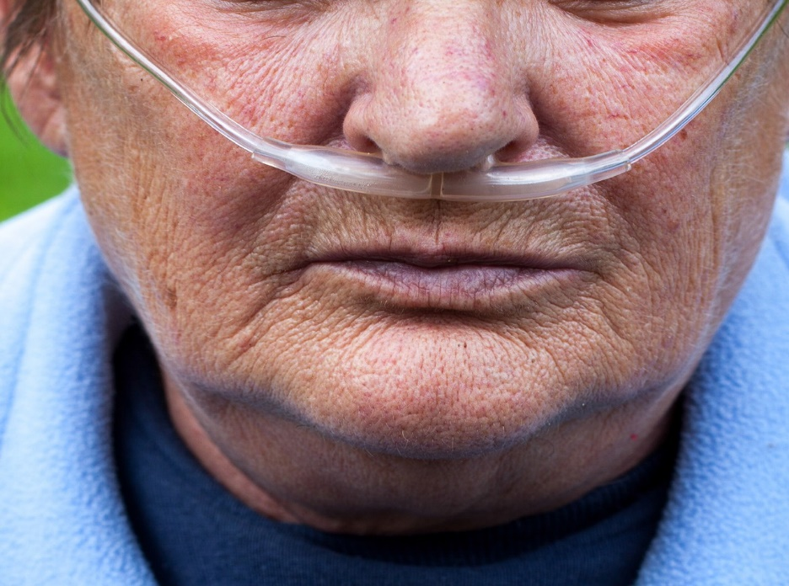
The Lennox and Addington County General Hospital, an Aetonix client in Southern Ontario, recently took the INSPIRED model a step further. Their organization has added aTouchAway,
our mobile platform for remote complex care management, to connect care teams with their COPD outpatients and their families at home. This innovative COPD Patient Outreach program includes:
» An individualized COPD Action Plan for each patient to help manage COPD and acute flare- ups so infections can be treated early to prevent emergency room visits
» A home-based education program that includes personalized information about proper respiratory care, medications and the use of inhalers, home oxygen (if prescribed) and useful every day coping techniques
» A dietician and physio-therapy assessment and action plan
» aTouchAway deployed on a mobile tablet device with connections to the patients’ care team and options to add family members or loved ones, or other supporting care professionals
At predefined intervals (in this case, weekly), the care team conducts virtual visits with their patients by using the simple video calling features of the platform. This is ensuring consistent contact without the need for travel. Between video visits, medication and activity reminders help keep patients on track and are viewed anytime by approved members of the patients’ care team.

The ability to acquire readings from home monitoring devices is also enabled – patients measure certain indicators (blood oxygen saturation levels, weight, blood pressure, pulse rate, blood glucose levels, activity/step count, body temperature) with the results automatically transmitted to aTouchAway. Questionnaires are also sent to certain patients or groups of patients allowing them to self-report on specific areas of concern (like the MRC Breathlessness Scale, for example).

Enabling and empowering patients with chronic conditions to take a more active role in their own care is having an incredible impact on reducing the burden on our strained healthcare systems. Patients not only report feeling less anxious, more in control, and better prepared, but acute exacerbations requiring emergency department or urgent clinical visits have declined dramatically.

After a year of implementing this program at their organization, the Lennox and Addington County General Hospital reported a 30-day COPD
readmissions reduction from 23% to 3.4%, an 85% reduction!



