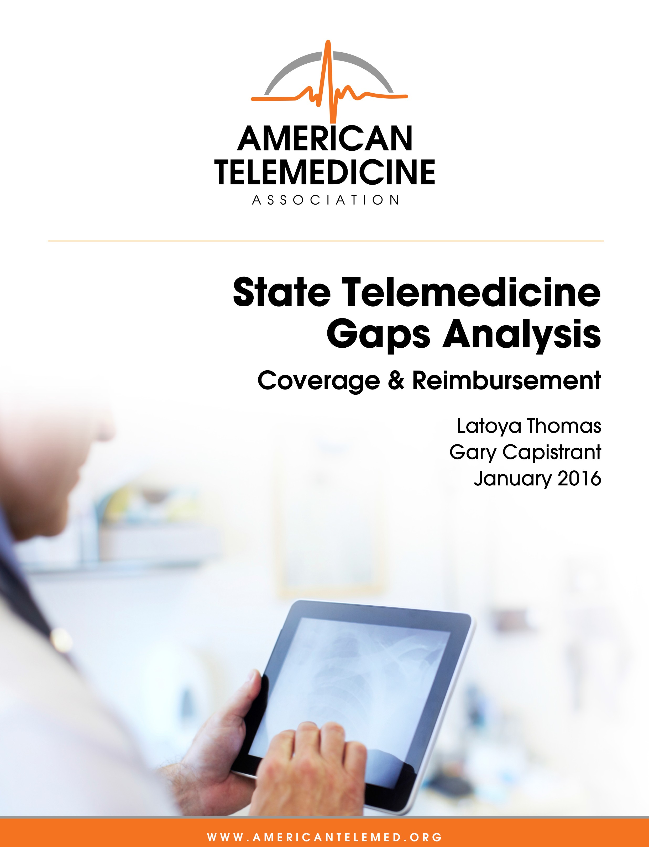



50 State Telemedicine Gaps Analysis
Coverage & Reimbursement

Latoya Thomas and Gary Capistrant

January 2016

None of the information contained in the Gaps Analysis Series or in this document constitutes legal advice. The information presented is informational and intended to serve as a reference for interested parties, and not to be relied upon as authoritative. Your own legal counsel should be consulted as appropriate.

TABLE OF CONTENTS

Executive Summary 1

Purpose 5

Overview 5

Assessment Methods 6
Scoring 6
Limitations 7

Indicators 8
Parity 8
Private Insurance 8
Medicaid 9
State Employee Health Plans 10
Medicaid Service Coverage & Conditions of Payment 11
Patient Setting 11
Eligible Technologies 14
Distance or Geography Restrictions 15
Eligible Providers 17
Physician-­‐provided Telemedicine Services 19
Mental and Behavioral Health Services 20
Rehabilitation Services 22
Home Health Services 23
Informed Consent 24
Telepresenter 25
Innovative Payment or Service Delivery Models 26

State Report Cards 28
Alabama 29
Alaska 30
Arizona 31

Arkansas 32
California 33
Colorado 34
Connecticut 35
Delaware 36
District of Columbia 37
Florida 38
Georgia 39
Hawaii 40
Idaho 41
Illinois 42
Indiana 43
Iowa 44
Kansas 45
Kentucky 46
Louisiana 47
Maine 48
Maryland 49
Massachusetts 50
Michigan 51
Minnesota 52
Mississippi 53
Missouri 54
Montana 55
Nebraska 56
Nevada 57
New Hampshire 58
New Jersey 59
New Mexico 60

New York 61
North Carolina 62
North Dakota 63
Ohio 64
Oklahoma 65
Oregon 66
Pennsylvania 67
Rhode Island 68
South Carolina 69
South Dakota 70
Tennessee 71
Texas 72
Utah 73
Vermont 74
Virginia 75
Washington 76
West Virginia 77
Wisconsin 78
Wyoming 79

Appendix 80
State Ratings – Map: Parity Laws for Private Insurance Coverage of Telemedicine 81
State Ratings – Map: Medicaid Policies for Telemedicine CoverageState Ratings 82
State Ratings – Map: State Employee Health Plan Laws for Telemedicine Coverage 83
State Ratings – Map: Medicaid Patient Setting 84
State Ratings – Map: Medicaid Eligible Technologies 85
State Ratings – Map: Medicaid Distance or Geography Restrictions 86
State Ratings – Map: Medicaid Eligible Providers 87
State Ratings – Map: Medicaid Physician-­‐provided Telemedicine Services 88
State Ratings – Map: Medicaid Mental and Behavioral Health Services 89

State Ratings – Map: Medicaid Rehabilitation Services 90
State Ratings – Map: Medicaid Home Health Services 91
State Ratings – Map: Medicaid Informed Consent 92
State Ratings – Map: Medicaid Telepresenter 93

References 94

EXECUTIVE SUMMARY
Payment and coverage for services delivered via telemedicine are some of the biggest challenges for telemedicine adoption. Patients and health care providers may encounter a patchwork of arbitrary insurance requirements and disparate payment streams that do not allow them to fully take advantage of telemedicine.

The American Telemedicine Association (ATA) has captured the complex policy landscape of 50 states with 50 different telemedicine policies, and translated this information into an easy to use format. This report complements our 50 State Gaps Analysis: Physician Practice Standards
& Licensure, and extracts and compares telemedicine coverage and reimbursement standards for every state in the U.S. ultimately leaving each state with two questions:

- “How does my state compare regarding policies that promote telemedicine adoption?”
- “What should my state do to improve policies that promote telemedicine adoption?”

Using data categorized into 13 indicators related to coverage and reimbursement, our analysis continues to reveal a mix of strides and stagnation in state-­‐based policy despite decades of evidence-­‐based research highlighting positive clinical outcomes and increasing telemedicine utilization.

Since our initial report in September 2014 11 states and D.C. have adopted policies that improved coverage and reimbursement of telemedicine-­‐provided services, while two states have adopted policies further restricting coverage (Figure 1).1

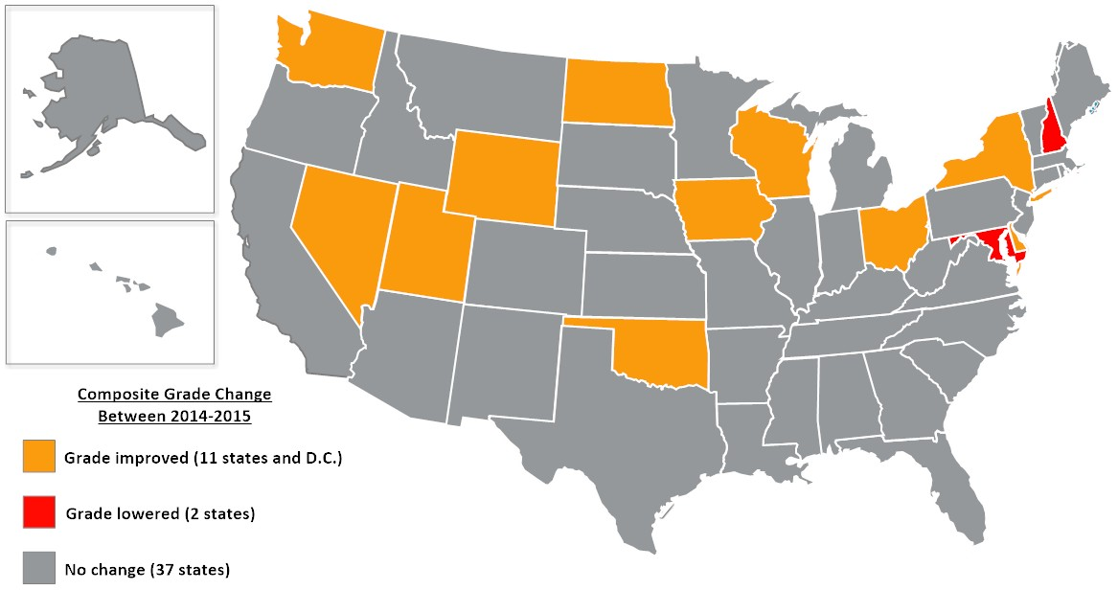
FIGURE 1 – Sept. 2014 -­‐ December 2015 Comparison

COMPOSITE GRADES

States have made efforts to improve their grades through the removal of arbitrary restrictions and adoption of laws ensuring coverage parity under private insurance, state employee health plans, and/or Medicaid plans, as indicated in Figure 2. Overall, there are more states now with above average grades, “A” or “B”, including Iowa which improved from an ‘F’ to ‘B’, than reported in September 2014.
FIGURE 2 – Sept. 2014 -­‐ December 2015 Comparison

Sept. 2014 Dec. 2015

A

B

C

F

0 5 10 15 20 25 30 35
NUMBER OF STATES

In recent months, five states (Delaware, Iowa, Mississippi, Nevada, and Oklahoma) have higher scores suggesting a supportive policy landscape that accommodates telemedicine adoption while one state saw a drop in their composite grade. New Hampshire dropped from an ‘A’ to ‘B’ as a result of adopted legislation that includes Medicaid telehealth coverage language similar to Medicare. Despite the adoption of a private insurance parity law earlier this year, Connecticut, like Rhode Island, continues to average the lowest composite score suggesting many barriers and little opportunity for telemedicine advancement (Table 1).

Table 1 – Composite Scores by State
State | Composite Grade | State | Composite Grade | State | Composite Grade | State | Composite Grade
AK | B | ID | C | MT | B | RI | F
AL | B | IL | C | NC | C | SC | B
AR | C | IN | C | ND | B | SD | B
AZ | B | KS | B | NE | B | TN | A
CA | B | KY | B | NH | B | TX | B
CO | B | LA | B | NJ | C | UT | B
CT | F | MA | B | NM | A | VA | A
DC | A | MD | B | NV | A | VT | B
DE | A | ME | A | NY | B | WA | B
FL | C | MI | B | OH | B | WI | C
GA | B | MN | B | OK | A | WV | C
HI | C | MO | B | OR | B | WY | B
IA | B | MS | A | PA | B

When broken down by the 13 indicators, the state-­‐by-­‐state comparisons reveal even greater disparities.

- Eight states have enacted telemedicine parity laws since the initial report in 2014. Of the 29 states that have telemedicine parity laws for private insurance, 22 of them and
  - scored the highest grades indicating policies that authorize state-­‐wide coverage, without any provider or technology restrictions (Figure 3). Less than half of the country, 22 states, ranked the lowest with failing scores for having either no parity law in place or numerous artificial barriers to parity. This is a significant improvement as more states adopt parity laws. Arkansas maintains a failing grade because it places arbitrary limits in its parity law.

- Forty-­‐eight state Medicaid programs have some type of coverage for telemedicine. Only eight states and D.C. scored the highest grades by offering more comprehensive coverage, with few barriers for telemedicine-­‐provided services (Figure 4). Delaware, Iowa, Nevada, and Oklahoma passed reforms that ensure parity coverage with little or no restrictions. Connecticut, Hawaii, Idaho, New Hampshire, Rhode Island, and West Virginia ranked the lowest with failing scores in this area. New Hampshire dropped from an ‘A’ to ‘B’ as a result of adopted legislation that includes Medicaid telehealth coverage language similar to Medicare.

- Another area of improvement includes coverage and reimbursement for telemedicine under state employee health plans. Twenty-­‐six states have some type of coverage for telehealth under one or more state employee health plan. Most states self-­‐insure their plans thus traditional private insurer parity language does not automatically affect them. Oregon is an exception which amended its parity law this year to include self-­‐

insured state employee health plans. 50 percent of the country is ranked the lowest with failing scores due to partial or no coverage of telehealth (Figure 5).

Regarding Medicaid, states continue to move away from the traditional hub-­‐and-­‐spoke model and allow a variety of technology applications. Twenty-­‐six states and D.C. do not specify a patient setting as a condition for payment of telemedicine (Figure 6). Aside from this, 36 states recognize the home as an originating site, while 18 states recognize schools and/or school-­‐ based health centers as an originating site (Figures 7-­‐8).

Vermont improved a letter grade because it now covers home remote patient monitoring. Half of the country ranks the lowest with failing scores either because they only cover synchronous only or provide no coverage for telemedicine at all. Idaho, Missouri, North Carolina and South Carolina prohibit the use of “cell phone video” to facilitate a telemedicine encounter (Figure 9).

There is still a national trend to allow state-­‐wide Medicaid coverage of telemedicine instead of focusing solely on rural areas or designated mileage requirements (Figure 10).

States are also increasingly using telemedicine to fill provider shortage gaps and ensure access to specialty care. Seventeen states and D.C. do not specify the type of healthcare provider allowed to provide telemedicine as a condition of payment (Figure 11). While 20 states ranked the lowest with failing scores for authorizing less than nine health provider types. Florida, Idaho, and Montana ranked the lowest with coverage for physicians only.

Overall, coverage of specialty services for telemedicine under Medicaid is a checkered board and no two states are alike.

- Ten states and D.C. rank the highest for coverage of telemedicine-­‐provided physician services and most states cover an office visit or consultations, with ultrasounds and echocardiograms being the least covered telemedicine-­‐provided services (Figure 12).

- For mental and behavioral health services, generally mental health assessments, individual therapy, psychiatric diagnostic interview exam, and medication management are the most covered via telemedicine. Twelve states and D.C. rank the highest for coverage of mental and behavioral health services (Figure 13). The lowest ranking states for all Medicaid services, scoring an ‘F’, are Connecticut and Rhode Island which have no coverage for telemedicine under their Medicaid plans.

- Although state policies vary in scope and application, five more states have expanded coverage to include telerehabilitation. Seventeen states are known to reimburse for telerehabilitative services in their Medicaid plans. Of those, 11 states rank the highest with telemedicine coverage for therapy services (Figure 14).

- Alaska is the only state with the highest ranking for telemedicine provided services under the home health benefit (Figure 15). Seventy percent of the country ranked the

lowest with failing scores due to a lack of telemedicine services covered under the home health benefit.

Finally, twenty-­‐seven states have unique patient informed consent requirements for telemedicine encounters (Figure 16). Twenty-­‐two states do not require a telepresenter during the encounter or on the premises (Figure 17).

PURPOSE

Patients and health care enthusiasts across the country want to know how their state compares to other states regarding telemedicine. While there are numerous resources that detail state telemedicine policies, they lack a state-­‐by-­‐state comparison. ATA has created a tool that identifies state policy gaps with the hope that states will respond with more streamlined policies that improve health care quality and reduce costs through accelerated telemedicine adoption.

This report fills that gap by answering the following questions:

- “How does my state’s telemedicine policies compare to others?”
- “Which states offer the best coverage for telemedicine provided services?”
- “Which states impose barriers to telemedicine access for patients and providers?”

It is important to note that this report is not a “how-­‐to guide” for telemedicine reimbursement. This is a tool aimed to serve as a reference for interested parties and to inform future policy decision making. The results presented in this document are based on information collected from state statutes, regulations, Medicaid program manuals/bulletins/fee schedules, state employee handbooks, and other federal and state policy resources. It is ATA’s best effort to interpret and understand each state’s policies. Your own legal counsel should be consulted as appropriate.

OVERVIEW

State lawmakers around the country are giving increased attention to how telehealth can serve their constituents. Policymakers seek to reduce health care delivery problems, contain costs, improve care coordination, and alleviate provider shortages. Many are using telemedicine to achieve these goals.

Over the past four years the number of states with telemedicine parity laws – that require private insurers to cover telemedicine-­‐provided services comparable to that of in-­‐person – has doubled.2 Moreover, Medicaid agencies are developing innovative ways to use telemedicine in their payment and delivery reforms resulting in 48 state Medicaid agencies with some type of coverage for telemedicine provided-­‐services.

Driving the momentum for telemedicine adoption is the creation of new laws that enhance access to care via telemedicine, and the amendment of existing policies with greater implications. Patients and health care providers are benefitting from policy improvements to existing parity laws, expanded service coverage, and removed statutory and regulatory barriers. While there are some states with exemplary telemedicine policies, lack of enforcement and general awareness have led to a lag in provider participation. Ultimately these pioneering telemedicine reforms have trouble reaching their true potential.

Other areas of concern include states that have adopted policies which are limiting in scope or prevent providers and patients from realizing the full benefits of telemedicine. Specifically, artificial barriers such as geographic discrimination and restrictions on provider and patient settings and technology type are harmful and counterproductive.

ASSESSMENT METHODS

Scoring

This report considers telemedicine coverage and reimbursement policies in each state based on two categories:

- Health plan parity
- Medicaid conditions of payment.

These categories were measured using 13 indicators. The indicators were chosen based on the most recent and generally accessible information assembled and published by state public entities. Using this information, we took qualitative characteristics based on scope of service, provider and patient eligibility, technology type, and arbitrary conditions of payment and assigned them quantitative values. States were given a certain number of points for each indicator depending on its effectiveness. The points were then used to rank and compare each state by indicator. We used a four-­‐graded system to rank and compare each state. This is based off of the scores given to each state by indicator. Each of the two categories was broken down into indicators – three indicators for health plan parity and 10 indicators for Medicaid conditions of payment.

Each indicator was given a maximum number of points ranging from 1 to 35. The aggregate score for each indicator was ranked on a scale of A through F based on the maximum number of points.

The report also includes a category to capture innovative payment and service delivery models implemented in each state. In addition to state supported networks in specialty care and correctional health, the report identifies a few federally subsidized programs and waivers that states can leverage to enhance access to health care services using telemedicine.

Limitations

Telemedicine policies in state health plans vary according to a number of factors – service coverage, payment methodology, distance requirements, eligible patient populations and health care providers, authorized technologies, and patient consent. These policy decisions can be driven by many considerations, such as budget, public health and safety needs, available infrastructure or provider readiness.

As such, the material in this report is a snapshot of information gathered through December 2015. The report relies on dynamic policies from payment streams that are often dissimilar and unaligned.

Illinois and Massachusetts have enacted “If, then” telemedicine coverage laws which prevent the enforcement of discriminatory practices such as an in-­‐person encounter.34 “If” the state regulated plan chooses to cover telemedicine-­‐provided services, “then” the plan is prohibited from requiring an in-­‐person visit. ATA does not interpret these statutes as parity laws.

We analyzed both Medicaid fee-­‐for-­‐service (FFS) and managed care plans. Benefit coverage under these plans vary by size and scope. We used physician, mental and behavioral health, home health, and rehabilitation services as a benchmark for our analysis. Massachusetts and New Hampshire do not cover telemedicine-­‐provided services under their FFS plans but do have some coverage under at least one of their managed care plans. As such, the analysis and scores are reflective of the telemedicine offerings in each program, and not the Medicaid program itself, regardless of size and scope.

We did not analyze state Children’s Health Insurance Plans (CHIP) plans. We are aware that states provide some coverage of telemedicine-­‐provided services for CHIP beneficiaries.
Additionally, some states recognize schools and/or school-­‐based health centers as originating sites, however we did not separately score or rank school-­‐based programs.

Although two states include coverage of telemedicine-­‐provided services under worker’s compensation plans, we did not analyze this coverage benefit. ATA may include these plans in future versions of this report as states extend coverage to include telemedicine under worker’s compensation and disability insurance.

Other notable observations in our analysis include state Medicaid plans that do not cover therapy services (i.e. physical therapy, occupational therapy, and speech language pathology).5 States with no coverage for these benefits were not applicable for scoring or ranking.

Additionally, some states policies can be conflicting. States like Arkansas and New York have enacted laws requiring telemedicine parity in their Medicaid plans. However, regulations and Medicaid provider manuals do not reflect all of these policy changes. In those cases, the analysis and scores are reflective of the authorized regulations and statutes enacted by law unless otherwise noted. Future reports will reflect changes in the law if applicable.

Also, this report is about what each state has “on paper”, not necessarily in service. Important factors, such as the actual provision and utilization of telemedicine services and provider collaboration to create service networks are beyond the scope of this report.

Indicators

Parity

    - Private Insurance

Full parity is classified as comparable coverage for telemedicine-­‐provided services to that of in-­‐ person services. Twenty-­‐eight states and the District of Columbia have enacted full parity laws. Only Arizona has enacted a partial parity law that requires coverage and reimbursement, but limits coverage to a certain geographic area (e.g., rural) or a predefined list of health care services. Since our initial report, some parity laws have included restrictions on patient settings. For this report’s purpose, we added this component to our methodology, and continue to measure other components of state policies that enable or impede parity for telemedicine-­‐provided services under private insurance health plans.

Scale – Private Insurance Parity
A | 7 points
B | 6 points
C | 5 points
F | ≤ 4 points

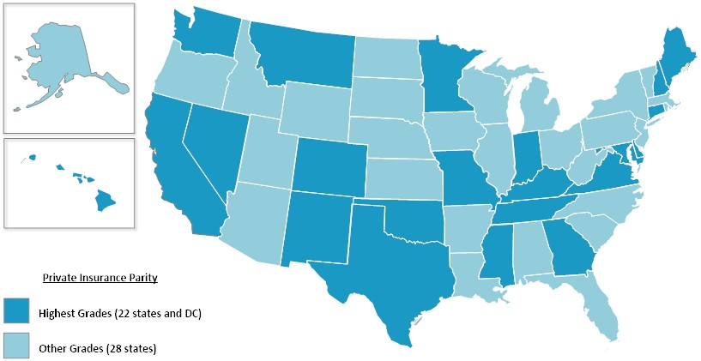
FIGURE 3 – Private Insurance Parity

States with the highest grades for private insurance telemedicine parity provide state-­‐wide coverage, and have no provider, technology, or patient setting restrictions (Figure 3). Among states with parity laws, Arizona, New York, and Vermont scored about average (C). New York and Vermont lawmakers have placed patient setting restrictions on those services eligible for coverage parity. While Arizona continues to limit coverage to interactive audio-­‐video only modalities and the types of services and conditions that are covered via telemedicine. Despite enacting a parity law in March 2015, Arkansas maintains a failing grade because it places arbitrary limits on patient location, eligible provider type, and requires an in-­‐person visit to establish a provider-­‐patient relationship. Forty-­‐four percent of the country ranks the lowest with failing (F) scores, a drop from the initial report.

    - Medicaid

Each state’s Medicaid plan was assessed based on service limits and patient setting restrictions. Other components assessed for all three plans include provider eligibility and the type of technology allowed were also examined to determine the state’s capacity to fully utilize telemedicine to overcome barriers to care. For this report’s purpose, we measured components of state policies that enable or impede parity for telemedicine-­‐provided services under Medicaid plans.

Scale – Medicaid Coverage
A | 14+ points
B | 10-­‐13 points
C | 6-­‐9 points
F | ≤ 5 points

Forty-­‐eight state Medicaid programs have some type of coverage for telemedicine.

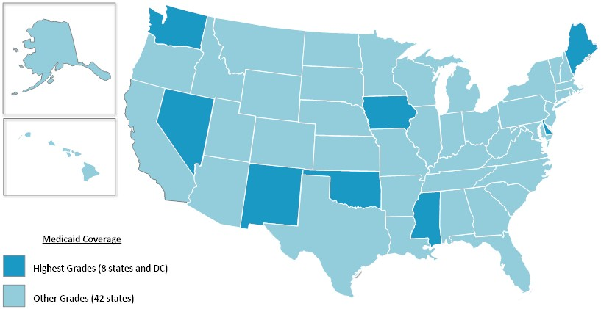
FIGURE 4 – Medicaid Coverage

Eight states and D.C. have the highest grades for Medicaid coverage of telemedicine-­‐provided services (Figure 4). Connecticut, Hawaii, Idaho, New Hampshire, Rhode Island, and West Virginia ranked the lowest with failing (F) scores. Iowa, Nevada, Oklahoma, and Washington have all made improvements to expand coverage of telemedicine for their Medicaid populations. Connecticut and Rhode Island are the only states without coverage for telemedicine under their Medicaid plans. Of the 48 states with coverage, Idaho offers the least amount of coverage for telemedicine-­‐provided services. While Hawaii, Idaho, New Hampshire, and West Virginia still apply geography limits in addition to restrictions on service coverage, provider eligibility, and patient setting.

    - State Employee Health Plans

We measured components of state policies that enable or impede parity for telemedicine-­‐ provided services under state-­‐employee health plans. Most states self-­‐insure their plans therefore traditional private insurer parity language does not automatically affect them.

Oregon is an exception which amended its parity law this year to include self-­‐insured state employee health plans.

Scale – State-­‐employee Health Plan Parity
A | 7 points
B | 6 points
C | 5 points
F | ≤ 4 points

Twenty-­‐six states provide some coverage for telemedicine under their state employee health plans with 26 states extending coverage under their parity laws (Figure 5). Most states self-­‐ insure their plans and 50 percent of the country is ranked the lowest with failing scores due to partial or no coverage of telehealth.

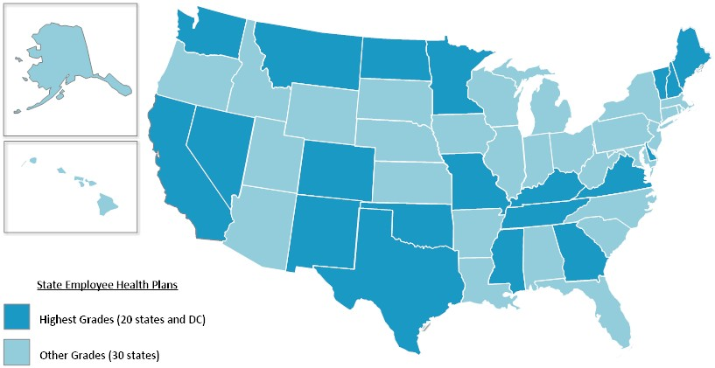
FIGURE 5 – State Employee Health Plan Coverage

Medicaid Service Coverage & Conditions of Payment

    - Patient Setting

In telemedicine policy, the place where the patient is located at the time of service is often referred to as the originating site (in contrast, to the site where the provider is located and often referred to as the distant site). The location of the patient is a contentious component of telemedicine coverage. A traditional approach to telemedicine coverage is to require that the patient be served from a specific type of health facility, such as a hospital or physician's office.

Left out by these approaches are the sites where people predominantly spend their time, such as homes, office/place of work, schools, or traveling around. With advances in decentralized computing power, such as cloud processing, and mobile telecommunications, such as 4G wireless, the current approach is to cover health services to patients wherever they are.

For this report, we measured components of state Medicaid policies that, for conditions of coverage and payment, broaden or restrict the location of the patient when telemedicine is used. The following sites are observed as qualified patient locations:

- Hospitals
- doctor’s office
- other provider’s office
- dentist office
- home
- federally qualified health center (FQHC)
- critical access hospital (CAH)
- rural health center (RHC)
- community mental health center (CMHC)
- sole community hospital
- school/school-­‐based health center (SBHC)
- assistive living facility (ALF)
- skilled nursing facility (SNF)
- stroke center
- rehabilitation/therapeutic health setting
- ambulatory surgical center
- residential treatment center
- health departments
- renal dialysis centers
- habilitation centers.

States received one (1) point for each patient setting authorized as an eligible originating site. Those states that did not specify an originating site were given the maximum score possible (20).

Scale – Medicaid: Patient Settings
A | 16+ points
B | 11-­‐15 points
C | 6-­‐10 points
F | ≤ 5 points

Twenty-­‐six states and D.C. do not specify a patient setting or patient location as a condition of payment for telemedicine (Figure 6).

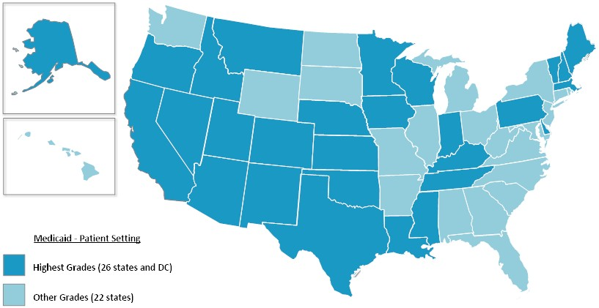
FIGURE 6 – Medicaid: Patient Setting

Aside from this, 36 states allow the home as an originating/patient site, while 18 states recognize schools and/or SBHCs as an originating site (Figures 7-­‐8).

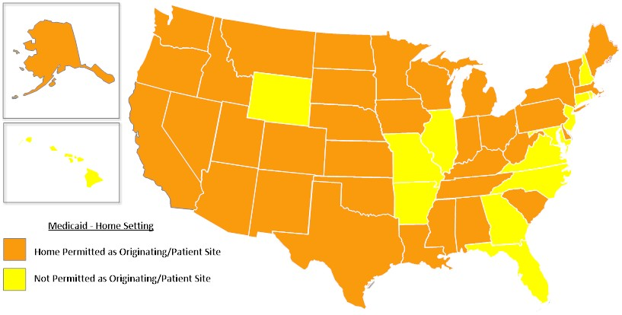
FIGURE 7 – Medicaid: Home Setting

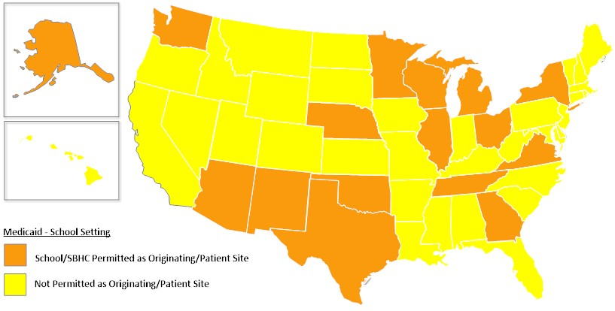
FIGURE 8 -­‐ Medicaid: School Setting

Six states ranked the lowest with failing (F) scores for designating less than six patient settings as originating sites with Florida and New Jersey ranking the lowest with only two eligible originating sites.

    - Eligible Technologies

Telemedicine includes the use of numerous technologies to exchange medical information from one site to another via electronic communications. The technologies closely associated with services enabled by telemedicine include videoconferencing, the transmission of still images (also known as store-­‐and-­‐forward), remote patient monitoring (RPM) of vital signs, and telephone calls. For this report, we measured components of state Medicaid policies that allow or prohibit the coverage and/or reimbursement of telemedicine when using these technologies.

Scale – Medicaid: Eligible Technologies
A | 5 points
B | 4 points
C | 3 points
F | ≤ 2 points

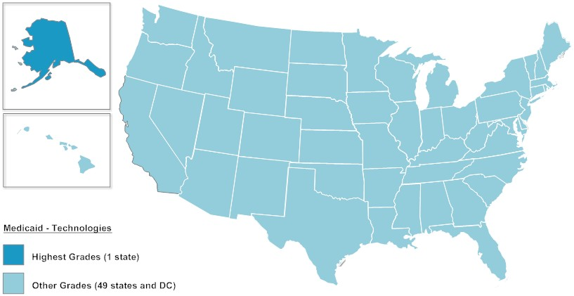
FIGURE 9 – Medicaid: Eligible Technologies

Seven states score above average on our scale with Alaska taking the highest ranking (Figure 9). The state covers telemedicine when providers use interactive audio-­‐video, store-­‐and-­‐forward, remote patient monitoring, and audio conferencing for some telemedicine encounters. Alaska, Minnesota, Mississippi, Nebraska, and Texas all cover telemedicine when using synchronous technology as well as store-­‐and-­‐forward and remote patient monitoring in some capacity. Fifty percent of the states rank the lowest with failing (F) scores either because they only cover synchronous only or provide no coverage for telemedicine at all.

Further, Idaho, Missouri, North Carolina and South Carolina prohibit the use of “cell phone video” or “video phone” to facilitate a telemedicine encounter.

    - Distance or Geography Restrictions

Distance restrictions are measured in miles and designate the amount of distance necessary between a distance site provider and patient as a condition of payment for telemedicine.
Geography is classified as rural, urban, metropolitan statistical area (MSA), defined population size, or health professional shortage area (HPSA).

We measured components of state Medicaid policies that apply distance or geography restrictions for conditions of coverage and payment when telemedicine is performed.

Scale – Medicaid: Distance & Geography Restrictions
A | 3 points
B | 2 points
C | 1 point
F | 0 points

Over the past year, states have made considerable efforts to rescind mileage requirements for covered telemedicine services. Nevada and Oklahoma now offer telemedicine state-­‐wide, while Iowa successfully removed its distance requirements. New Hampshire adopted legislation that includes geographically restricted language similar to Medicare. Indiana has statutory authority to remove their mileage requirements for all distance site providers but chooses to enforce the mileage requirement for some eligible providers. Earlier this year, Ohio Medicaid approved a regulation that would expand coverage of telemedicine services, and includes a five mile distance restriction as a condition of payment.

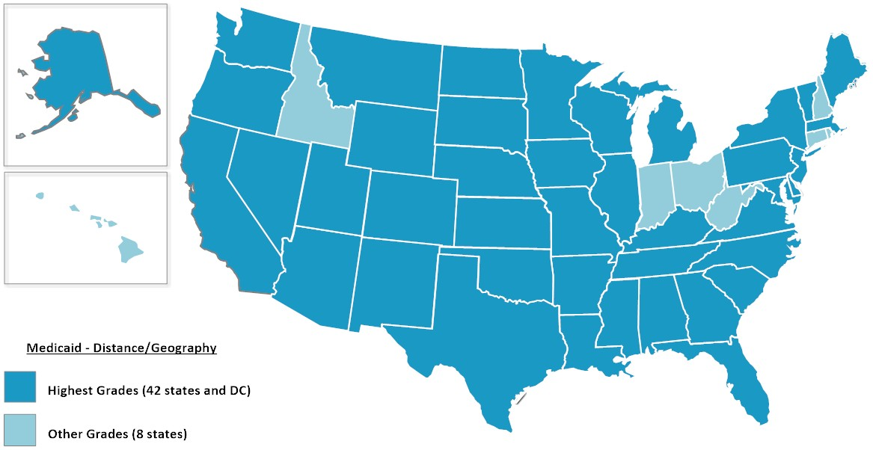
FIGURE 10 -­‐ Medicaid: Distance/Geography Restrictions

Eighty-­‐six percent of the states cover telemedicine services state-­‐wide without distance restrictions or geographic designations (Figure 10). This evidence dispels the misconception that telemedicine is only appropriate for rural settings only.

    - Eligible Providers

Most states allow physicians to perform telemedicine encounters within their scope of practice.

We measured components of state Medicaid policies that, for conditions of coverage and payment, broaden or restrict the types of distant site providers allowed to perform the telemedicine encounter. The following providers are observed as qualified health care professionals for covered telemedicine-­‐provided services:

- physician (MD and DO)
- podiatrist
- chiropractor
- optometrist
- genetic counselor
- dentist
- physician assistant (PA)
- nurse practitioner (NP)
- registered nurse
- licensed practical nurse
- certified nurse midwife
- clinical nurse specialist
- psychologist
- marriage and family therapist
- clinical social worker (CSW)
- clinical counselor
- behavioral analyst
- substance abuse/addictions specialist
- clinical therapist
- pharmacist
- physical therapist
- occupational therapist
- speech-­‐language pathologist and audiologist
- registered dietitian/nutritional professional
- diabetes/asthma/nutrition educator
- home health aide
- home health agency (HHA)
- FQHC
- CAH
- RHC
- CMHC
- SNF.

Each state received two (2) points for designating a physician, and one (1) point for each additional eligible provider authorized to provide covered telemedicine services. Those states that did not specify an eligible provider were given the maximum score possible (35).

Scale – Medicaid: Eligible Providers
A | 25+ points
B | 17-­‐24 points
C | 9-­‐16 points
F | ≤ 8 points

Sixteen states and D.C. do not specify the type of health care provider allowed to provide telemedicine as a condition of payment (Figure 11).

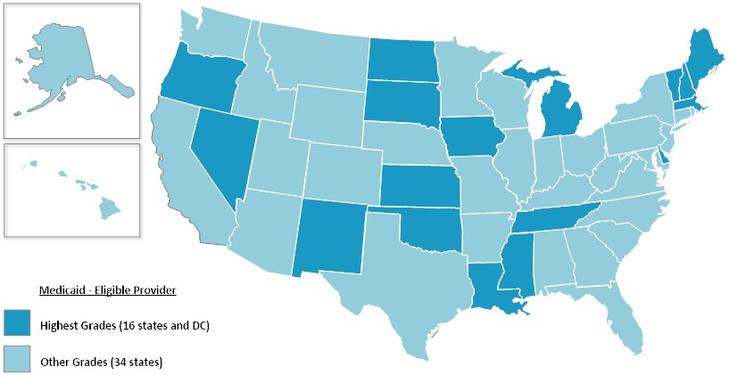
FIGURE 11 -­‐ Medicaid: Eligible Providers

Other interesting trends include Alaska, California, and Illinois which cover services when provided by a podiatrist. Alaska, California, and Kentucky cover services when provided by a chiropractor. California, Kentucky, and Washington are the only states to specify coverage for services when provided by an optometrist, while Arizona, California, and New York will cover services provided by a dentist. Although CMS has issued guidance clarifying their position on coverage for services related to autism spectrum disorder, only New Mexico, Oklahoma, and Washington specify coverage for telemedicine when provided by behavioral analysts. This trend is unique because these specialists are critical for the treatment of autism spectrum disorders. New Mexico, Oklahoma, Virginia, West Virginia, and Wyoming specify coverage for telemedicine when provided by a substance abuse or addiction specialist.

Eighteen states ranked the lowest with failing (F) scores for authorizing less than nine health provider types. Florida, Idaho, and Montana ranked the lowest with coverage for physicians only.

    - Physician-­‐provided Telemedicine Services

Physician-­‐provided telemedicine services are commonly covered and reimbursed by Medicaid health plans. However, some plans base coverage on a prescribed set of health conditions or services, place restrictions on patient or provider settings, the frequency of covered telemedicine encounters, or exclude services performed by other medical professionals.
For this report, we measured components of state Medicaid policies that broaden or restrict a physician’s ability to use telemedicine for conditions of coverage and payment.

Scale – Medicaid: Physician-­‐provided Services
A | 13 points
B | 10-­‐12 points
C | 7-­‐9 points
F | ≤ 6 points

Eleven states and D.C. rank the highest for coverage of telemedicine-­‐provided physician services (Figure 12). These states have no restrictions on service coverage or additional conditions of payment for services provided via telemedicine. Additionally, these states also allow a physician assistant and/or advanced practice nurse as eligible distant site providers.

Moreover, most states cover an office visit or consultations, with ultrasounds and echocardiograms being the least covered telemedicine-­‐provided services.

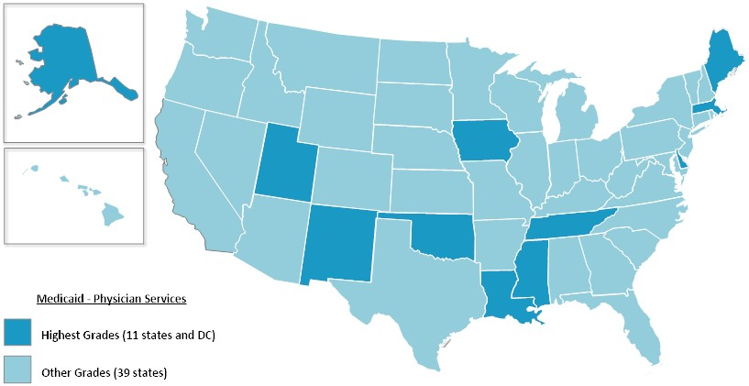
FIGURE 12 – Medicaid: Physician Services

The lowest ranking states, which scored an F, are Connecticut and Rhode Island which have no coverage for telemedicine under their Medicaid plans and Iowa and Ohio with limited service coverage and other arbitrary restrictions.

      - Mental and Behavioral Health Services

According to ATA’s telemental health practice guidelines, telemental health consists of the practice of mental health specialties at a distance using video-­‐conferencing. The scope of services that can be delivered using telemental health includes: mental health assessments, substance abuse treatment, counseling, medication management, education, monitoring, and collaboration. Forty-­‐eight states have some form of coverage and reimbursement for mental health provided via telemedicine video-­‐conferencing. While the number of states with coverage in this area suggests enhanced access to mental health services, it is important to note that state policies for telemental health vary in specificity and scope.

We measured components of state Medicaid policies that broaden or restrict the types of providers allowed to perform the telemedicine encounter, telemedicine coverage for mental and behavioral health services.

Scale – Medicaid: Mental and Behavioral Health Services
A | 14 points
B | 10-­‐13 points
C | 6-­‐9 points
F | ≤ 5 points

Generally the telemedicine-­‐provided services that are most often covered under state Medicaid plans include mental health assessments, individual therapy, psychiatric diagnostic interview exam, and medication management. Twelve states and D.C. rank the highest for coverage of mental and behavioral health services (Figure 13). These states have no restrictions on service coverage or additional conditions of payment for services provided via telemedicine.
Additionally, these states also classify at least one other medical professional (i.e. physician assistant and advanced practice nurse) as an eligible distant site provider.

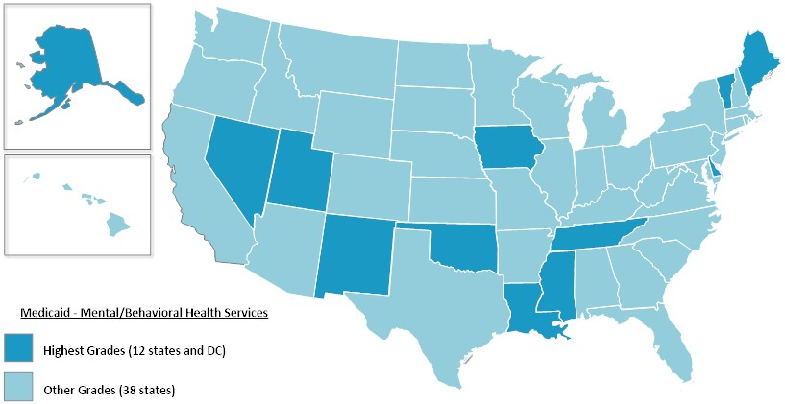
FIGURE 13 – Medidcaid: Mental/Behavioral Health Services

It is also more common for states with telemental health coverage to allow physicians that are psychiatrists, advanced practice nurses with clinical specialties, and psychologists to perform the telemedicine encounter. However, many states allow non-­‐medical providers to perform and reimburse for the telemedicine encounter. States including Alaska, Arizona, Arkansas, California, Hawaii, Indiana, Kentucky, Michigan, Minnesota, Nevada, New Hampshire, New Mexico, New York, North Carolina, Ohio, Oklahoma, Texas, Virginia, Washington, West Virginia and Wyoming cover telemedicine when performed by a licensed social worker. Alaska, Arizona, Arkansas, California, Indiana, Kentucky, Minnesota, Nevada, New Mexico, Ohio, Oklahoma,

Texas, Virginia, Washington, West Virginia, and Wyoming cover telemedicine when provided by a licensed professional counselor.

Further, New Mexico, Oklahoma, and Washington are the only states to specify coverage for telemedicine when provided by behavioral analysts. This trend is unique because these specialists are critical for the treatment of autism spectrum disorders.

The lowest ranking states, which scored an F, are Connecticut and Rhode Island which have no coverage for telemedicine under their Medicaid plans. Iowa improved their grade from an ‘F’ to ‘B’ due to expanded service coverage offered through a contracted plan.

- Rehabilitation Services

The ATA telerehabilitation guidelines define telerehabilitation as the “delivery of rehabilitation services via information and communication technologies. Clinically, this term encompasses a range of rehabilitation and habilitation services that include assessment, monitoring, prevention, intervention, supervision, education, consultation, and counseling”. Rehabilitation professionals utilizing telerehabilitation include: neuropsychologists, speech-­‐language pathologists, audiologists, occupational therapists, and physical therapists.
We measured components of state Medicaid policies that broaden or restrict the types of providers allowed to perform the telemedicine encounter, restrictions on patient or provider settings, and coverage for telerehabilitation services.

Scale – Medicaid: Rehabilitation Services
A | 6+ points
B | 4-­‐5 points
C | 2-­‐3 points
F | ≤ 1 points

Only 37 states were analyzed, scored and ranked for this indicator. Thirteen states and D.C. do not cover rehabilitation services for their Medicaid recipients. Although state policies vary in scope and application, 17 states are known to reimburse for telerehabilitative services in their Medicaid plans. Of those, 11 states rank the highest with telemedicine coverage for therapy services (Figure 14).

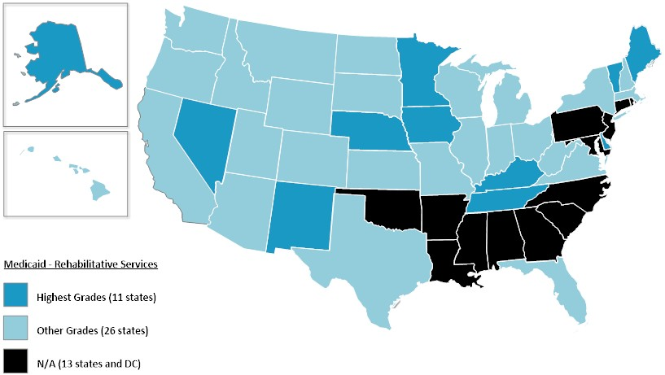
FIGURE 14 – Medicaid: Rehabilitation Services

Further, of the 25 states that cover home telemedicine, only Alaska, Colorado, Delaware, Iowa, Kentucky, Maine, Nebraska, Nevada, New Mexico, and Tennessee reimburse for telerehabilitative services within the home health benefit.

- Home Health Services

One well-­‐proven form of telemedicine is remote patient monitoring. Remote patient monitoring may include two-­‐way video consultations with a health provider, ongoing remote measurement of vital signs or automated or phone-­‐based check-­‐ups of physical and mental well-­‐being. The approach used for each patient should be tailored to the patient’s needs and coordinated with the patient’s care plan.

For this report, we measured components of state Medicaid policies that broaden or restrict the types of providers allowed to perform the telemedicine encounter and services covered for home health services.

Scale – Medicaid: Home Health
A | 6+ points
B | 4-­‐5 points
C | 2-­‐3 points
F | ≤ 1 point

Alaska is the only state with the highest ranking for telemedicine provided services under the home health benefit (Figure 15).

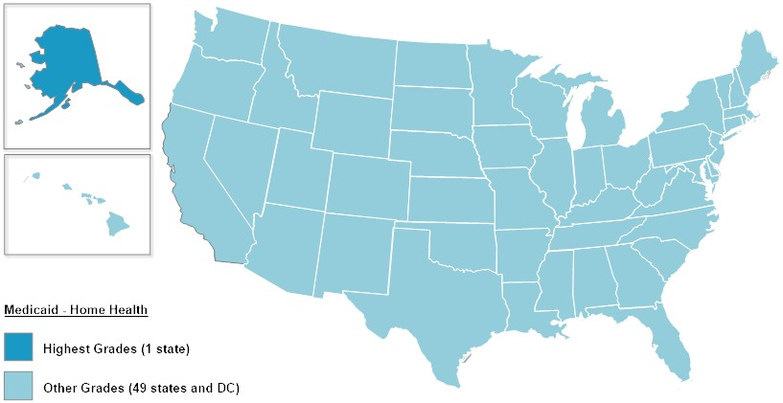
FIGURE 15 – Medicaid: Home Health Services

Of the 25 states that cover home telemedicine, only Alaska, Colorado, Delaware, Iowa, Kentucky, Maine, Nebraska, Nevada, New Mexico, and Tennessee reimburse for telerehabilitative services within the home health benefit. Additionally, Pennsylvania is the only state that will cover telemedicine in the home when provided by a caregiver.

Arizona no longer covers telemedicine under their home health benefit. Seventy percent of the country ranked the lowest with failing (F) scores due to a lack of telemedicine services covered under the home health benefit.

- Informed Consent

We measured components of state Medicaid and medical licensing board policies that apply more stringent requirements for telemedicine as opposed to in-­‐person services. States were evaluated based on requirements for written or verbal informed consent, or unspecified methods of informed consent before a telemedicine encounter can be performed.

Scale – Medicaid: Informed Consent
A | 4 points
B | 3 points
C | 2 points
F | ≤ 1 point

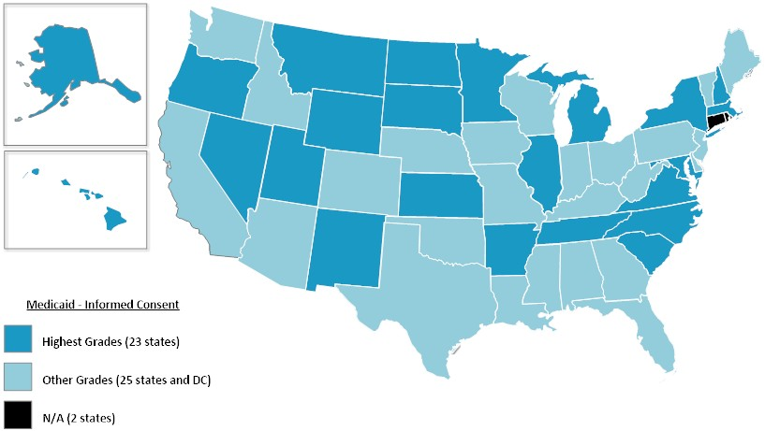
FIGURE 16 – Medicaid: Informed Consent

Of the 27 states with informed consent requirements, 19 states have such requirements imposed by their state Medical Board (Figure 16). Although their Medicaid programs do not cover telehealth, Rhode Island and Connecticut’s Medical Boards require informed consent.

- Telepresenter

We measured components of state Medicaid and medical licensing board policies that apply more stringent requirements for telemedicine as opposed to in-­‐person services. States were evaluated based on requirements for a telepresenter or health care provider on the premises during a telemedicine encounter.

Scale – Medicaid: Telepresenter
A | 3 points
B | 2 points
C | 1 point
F | 0 points

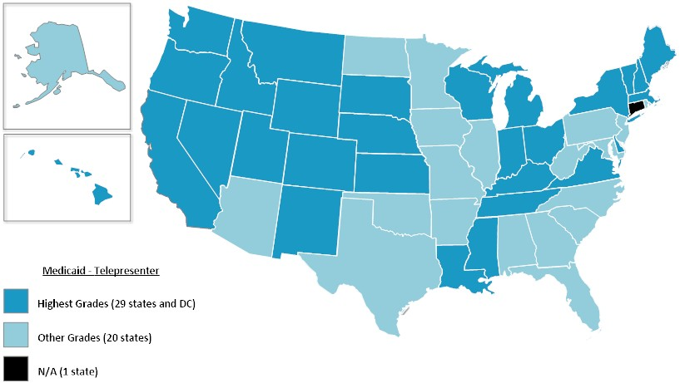
FIGURE 17 – Medicaid: Telepresenter

Alabama, Georgia, Iowa, Maryland, Minnesota, Missouri, New Jersey, North Carolina, and West Virginia only require a health care provider to be on the premises and not physically with the patient during a telemedicine encounter (Figure 17). Although Connecticut and Rhode Island have no telemedicine coverage under Medicaid, their Medical Boards do not require a telepresenter for telemedicine related services.

Innovative Payment or Service Delivery Models

This report also includes a category to capture innovative payment and service delivery models implemented in each state. In addition to state supported networks in specialty care and correctional health, the report identifies a few federally subsidized programs and waivers that states have leveraged to enhance access to health care services using telemedicine.

Over the years, states have increasingly used managed care organizations (MCOs) to create payment and delivery models involving capitated payments to provide better access to care and follow-­‐up for patients, and also to control costs. The variety of payment methods and other operational details among Medicaid managed care arrangements is a useful laboratory for devising, adapting and advancing long-­‐term optimal health delivery. MCOs experimenting with innovative delivery models including medical homes and dual-­‐eligible coordination have incorporated telemedicine as a feature of these models especially because it helps to reduce costs related to emergency room use and hospital admissions.

Twenty-­‐four states authorize telemedicine-­‐provided services under their Medicaid managed care plans. Most notably, Massachusetts and New Hampshire offer coverage under select managed care plans but not under FFS.

The federal Affordable Care Act (ACA) offers states new financing and flexibility to expand their Medicaid programs, as well as to integrate Medicare and Medicaid coverage for dually eligible beneficiaries (“duals”). Michigan, New York and Virginia are the only states that extend coverage of telemedicine-­‐provided services to their dual eligible population through the Centers for Medicare and Medicaid Services (CMS) Capitated Financial Alignment Model for Medicare-­‐Medicaid Enrollees.6

The ACA also includes a health home option to better coordinate primary, acute, behavioral, and long-­‐term and social service needs for high-­‐need, high-­‐cost beneficiaries. The chronic conditions include mental health, substance use disorder, asthma, diabetes, heart disease, overweight (body mass index over 25), and other conditions that CMS may specify.

Nineteen states have approved health home state plan amendments (SPAs) from CMS.7 Alabama, Iowa, Maine, New York, Ohio, and West Virginia are the only states that have incorporated some form of telemedicine into their approved health home proposals.

Medicaid plans have several options to cover remote patient monitoring, usually under a federal waiver such as the Home and Community-­‐based Services (HCBS) under Social Security Act section 1915(c).8 States may apply for this waiver to provide long-­‐term care services in home and community settings rather than institutional settings. Kansas, Pennsylvania, and South Carolina are the only states that have used their waivers to provide telemedicine to beneficiaries in the home, specifically for the use of home remote patient monitoring.

State Report Cards

Telemedicine in Alabama
PARITY: |  | GAPS:
Private Insurance | F | - AL has no parity law and is bordered by GA, MS, and TN which enacted private insurance parity laws.  Medicaid  - Limited patient settings include hospital, physician’s office, FQHC, CAH, RHC, CMHC. The home is recognized as an originating site under the Health Home model for RPM use only.  - Eligible providers are restricted to MDs/DOs, PAs, and NPs for physician and mental health services.  - Requires written informed consent and a telepresenter on the premises.  Innovation  - CMS approved Health Home program based off of the successful Patient 1st medical home model uses home health nurses employed by the Department of Health to remotely monitor vital signs for patients with diabetes, hypertension, and congestive heart disease. Although the use of RPM was approved for this program, there is no mention of using other telemedicine modalities.
Medicaid9 | C
State Employee Health Plan | F
MEDICAID SERVICE COVERAGE & CONDITIONS OF PAYMENT:
Patient Setting | C
Eligible Technologies | C
Distance or Geography Restrictions | A
Eligible Providers | F
Physician-­‐provided Services | B
Mental/behavioral Health Services10 | B
Rehabilitation | N/A
Home Health11 | F
Informed Consent | F
Telepresenter | B
INNOVATIVE PAYMENT OR SERVICE DELIVERY MODELS:
State-­‐wide Network
Medicaid Managed Care
Medicare-­‐Medicaid Dual Eligibles
Health Home12 | ✔
HCBS Waiver
Corrections | ✔
Other13 | ✔

Telemedicine in Alaska
PARITY: |  | GAPS:
Private Insurance | F | - AK has no parity law.  Medicaid  - Telemedicine coverage under the Medicaid plan is broad and the least restrictive compared to other states. However not all benefits are covered when using telemedicine, thus leaving out services including dental and ocular care.  - Will cover services when delivered using dedicated audio conferencing system.  - Alaska Medicaid covers school-­‐based services when provided via telemedicine: audiology, behavioral health, nursing, occupational therapy, physical therapy, and speech-­‐language therapy.14  - Although Medicaid does not require a telepresenter as a condition of payment, the state’s Medical Board has such practice standard requirements.
Medicaid15-­‐21 | B
State Employee Health Plan | F
MEDICAID SERVICE COVERAGE & CONDITIONS OF PAYMENT:
Patient Setting | A
Eligible Technologies | A
Distance or Geography Restrictions | A
Eligible Providers | B
Physician-­‐provided Services | A
Mental/behavioral Health Services22-­‐23 | A
Rehabilitation24 | A
Home Health25 | A
Informed Consent | A
Telepresenter | C
INNOVATIVE PAYMENT OR SERVICE DELIVERY MODELS:
State-­‐wide Network
Medicaid Managed Care | N/A
Medicare-­‐Medicaid Dual Eligibles
Health Home
HCBS Waiver
Corrections
Other

Telemedicine in Arizona |  |  | 
PARITY: |  | GAPS:
Private Insurance | C | - Arizona’s partial parity law was enacted in 2013. Coverage under private and state employee health plans applies to rural areas and only seven health services.26  Medicaid  - AZ has varying service coverage under its Medicaid FFS, managed care plans, and Indian Health Service. This includes echocardiography, retinal screening, medical nutrition therapy and patient education for diabetes and chronic kidney disease care.  - The agency now covers teledentistry.  - The eligible distant site provider and patient site varies according to the participating AHCCCS program.  - Does not cover for the use of RPM.  Innovation  - AZ Telemedicine Program offers clinical, educational, and administrative services via telemedicine across the state.
Medicaid27-­‐28 | B
State Employee Health Plan | C
MEDICAID SERVICE COVERAGE & CONDITIONS OF PAYMENT:
Patient Setting | A
Eligible Technologies29 | B
Distance or Geography Restrictions | A
Eligible Providers | C
Physician-­‐provided Services30 | B
Mental/behavioral Health Services | B
Rehabilitation | F
Home Health | F
Informed Consent | B
Telepresenter | C
INNOVATIVE PAYMENT OR SERVICE DELIVERY MODELS:
State-­‐wide Network31 | ✔
Medicaid Managed Care32 | ✔
Medicare-­‐Medicaid Dual Eligibles
Health Home
HCBS Waiver
Corrections | ✔
Other

Telemedicine in Arkansas
PARITY: |  | GAPS:
Private Insurance | F | Progress  - Arkansas’s parity law was enacted in 2015 and includes telemedicine coverage for physician-­‐ provided services under private insurance, Medicaid, and state employee health plans. Effective January 2016, the new parity law will affect payment for physician services. This is the only telemedicine parity law that requires an in-­‐person encounter as a condition of coverage and payment.  Medicaid  - Effective January 2016, the new parity law will affect payment for physician services.  - Telemedicine coverage under Medicaid includes limits on service coverage, frequency, patient settings and eligible distant site providers.  - One of few states with coverage for fetal echography and echocardiography.  - Medicaid also places frequency limits on covered telemedicine services.  - Requires a telepresenter at the originating site.  - Coverage for interactive audio-­‐video only.  Innovation  - Specialty maternal-­‐fetal telemedicine network operated by University of Arkansas.
Medicaid | C
State Employee Health Plan | F
MEDICAID SERVICE COVERAGE & CONDITIONS OF PAYMENT:
Patient Setting | C
Eligible Technologies | F
Distance or Geography Restrictions | A
Eligible Providers | F
Physician-­‐provided Services33 | C
Mental/behavioral Health Services34 | B
Rehabilitation | N/A
Home Health | F
Informed Consent | A
Telepresenter | C
INNOVATIVE PAYMENT OR SERVICE DELIVERY MODELS:
State-­‐wide Network
Medicaid Managed Care
Medicare-­‐Medicaid Dual Eligibles
Health Home
HCBS Waiver
Corrections
Other35-­‐36 | ✔

Telemedicine in California

PARITY: GAPS:

Private Insurance A
Medicaid41-­‐43 B
State Employee Health Plan A

MEDICAID SERVICE COVERAGE & CONDITIONS OF PAYMENT:
Patient Setting A
Eligible Technologies44-­‐45 C

Progress
- One of few Medicaid programs that covers teledentistry.

Private Insurance
- California’s private insurance parity law was enacted in 1996.37

Medicaid

Distance or Geography Restrictions
- • Coverage for interactive audio-­‐video and store-­‐ and-­‐forward for the purposes of dermatology,

Eligible Providers C
Physician-­‐provided Services B
ophthalmology, and dentistry.
- Also recognizes OT, PT, speech language therapists, and audiologists as eligible providers

Mental/behavioral Health
Services46
- of telemedicine but offers no billing details for
rehabilitation services via telehealth.

Rehabilitation F
Home Health F
Informed Consent B
Telepresenter A

INNOVATIVE PAYMENT OR SERVICE DELIVERY MODELS:
State-­‐wide Network47 ✔
Medicaid Managed Care ✔
Medicare-­‐Medicaid Dual Eligibles
Health Home HCBS Waiver
Corrections ✔
Other
- 2014 law allows verbal or written method of collection to satisfy patient informed consent requirements.38-­‐40

Innovation
- California Telehealth Network supports broadband connections of many institutions state-­‐wide.

Telemedicine in Colorado |  |  | 
PARITY: |  | GAPS:
Private Insurance | A | Progress  - Colorado enacted a law to improve the existing parity law and remove the rural restrictions. Effective 2017, the state will have state-­‐wide telehealth parity coverage for all private and state employee health plans in the state.48  - Removed rural and distance restrictions that were applied under Medicaid managed care.  Medicaid  - CO Medicaid imposes restrictions on covered services and designates certain provider types to render the service.  - The program will pay certain facilities an originating site but that does not limit reimbursement to a distant site provider if a patient is located elsewhere.  - Coverage for interactive audio-­‐video only for physician, mental/behavioral health services, and speech therapy services.  - Coverage only for RPM for chronic disease management under the home health benefit.49 -­‐  51  - Requires written informed consent.  Opportunities  - Colorado Telehealth Network supports broadband connections of many institutions state-­‐wide.
Medicaid52-­‐53 | B
State Employee Health Plan | A
MEDICAID SERVICE COVERAGE & CONDITIONS OF PAYMENT:
Patient Setting | A
Eligible Technologies | C
Distance or Geography Restrictions | A
Eligible Providers | C
Physician-­‐provided Services | B
Mental/behavioral Health Services | B
Rehabilitation | B
Home Health | C
Informed Consent | F
Telepresenter | A
INNOVATIVE PAYMENT OR SERVICE DELIVERY MODELS:
State-­‐wide Network54 | ✔
Medicaid Managed Care55 | ✔
Medicare-­‐Medicaid Dual Eligibles
Health Home
HCBS Waiver
Corrections
Other

Telemedicine in Connecticut
PARITY: |  | GAPS:
Private Insurance | A | Progress  - CT enacted a telemedicine parity law for private insurance coverage in 2015.56  - Home Health workgroup having conversations about RPM reimbursement under Medicaid57  Medicaid  - No coverage under Medicaid although the statute authorizes a telemedicine demonstration for beneficiaries located at FQHCs.58  - The agency will not cover information or services provided to a client by a provider electronically or over the telephone.
Medicaid | F
State Employee Health Plan | F
MEDICAID SERVICE COVERAGE & CONDITIONS OF PAYMENT:
Patient Setting | F
Eligible Technologies | F
Distance or Geography Restrictions | F
Eligible Providers | F
Physician-­‐provided Services | F
Mental/behavioral Health Services | F
Rehabilitation | N.A
Home Health | F
Informed Consent | N/A
Telepresenter | N/A
INNOVATIVE PAYMENT OR SERVICE DELIVERY MODELS:
State-­‐wide Network
Medicaid Managed Care
Medicare-­‐Medicaid Dual Eligibles
Health Home
HCBS Waiver
Corrections
Other

Telemedicine in Delaware
PARITY: |  | GAPS:
Private Insurance | A | Progress  - DE enacted telemedicine parity law introduced in 2015.59  Medicaid  - Coverage for any services included in the SPA that would be provided in a face-­‐to-­‐face setting including the home.60  - Also includes coverage under school-­‐based program.
Medicaid | A
State Employee Health Plan | A
MEDICAID SERVICE COVERAGE & CONDITIONS OF PAYMENT:
Patient Setting | A
Eligible Technologies | F
Distance or Geography Restrictions | A
Eligible Providers | A
Physician-­‐provided Services | A
Mental/behavioral Health Services | A
Rehabilitation | A
Home Health | B
Informed Consent | B
Telepresenter | A
INNOVATIVE PAYMENT OR SERVICE DELIVERY MODELS:
State-­‐wide Network
Medicaid Managed Care | ✔
Medicare-­‐Medicaid Dual Eligibles
Health Home
HCBS Waiver
Corrections
Other

Telemedicine in D.C. |  |  | 
PARITY: |  | GAPS:
Private Insurance61 | A | Progress  - DC Medicaid will draft and publish rulemaking to further define appropriate billing conditions for telemedicine in 2016.  - D.C. parity law was enacted in 2013 and requires coverage for telemedicine-­‐provided services under private plans and Medicaid.  Medicaid  - The law requires Medicaid to cover and reimburse for services via telemedicine if they are covered in-­‐person. However, provider manuals have not been updated to reflect the current law.  - No explicit coverage of store-­‐and-­‐forward or remote patient monitoring.
Medicaid62 | A
State Employee Health Plan | A
MEDICAID SERVICE COVERAGE & CONDITIONS OF PAYMENT:
Patient Setting | A
Eligible Technologies | F
Distance or Geography Restrictions | A
Eligible Providers | A
Physician-­‐provided Services | A
Mental/behavioral Health Services | A
Rehabilitation | N/A
Home Health | C
Informed Consent | B
Telepresenter | A
INNOVATIVE PAYMENT OR SERVICE DELIVERY MODELS:
State-­‐wide Network
Medicaid Managed Care | ✔
Medicare-­‐Medicaid Dual Eligibles
Health Home
HCBS Waiver
Corrections
Other

Telemedicine in Florida |  |  | 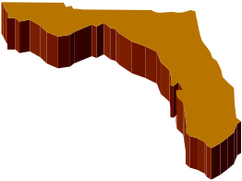
PARITY: |  | GAPS:
Private Insurance | F | Progress  - Proposed regulations to expand coverage under Medicaid63  Private Insurance  - Bordered by GA which has a private insurance parity law. No parity legislation introduced in 2015.  Medicaid  - Covers a limited number of services provided by physicians, NPs, and PAs.  - Originating patient sites are limited to hospitals and physician’s office.  - Coverage for interactive audio-­‐video only.  - Requires written informed consent and telepresenter.  FL Medicaid has transitioned a majority of their beneficiaries to managed care. Therefore, providers have more flexibility to negotiate coverage for telehealth-­‐provided services.
Medicaid64 | C
State Employee Health Plan | F
MEDICAID SERVICE COVERAGE & CONDITIONS OF PAYMENT:
Patient Setting | F
Eligible Technologies | F
Distance or Geography Restrictions | A
Eligible Providers | F
Physician-­‐provided Services | B
Mental/behavioral Health Services | B
Rehabilitation | F
Home Health | F
Informed Consent | F
Telepresenter | C
INNOVATIVE PAYMENT OR SERVICE DELIVERY MODELS:
State-­‐wide Network
Medicaid Managed Care
Medicare-­‐Medicaid Dual Eligibles
Health Home
HCBS Waiver
Corrections
Other

Telemedicine in Georgia
PARITY: |  | GAPS:
Private Insurance | A | Private Insurance  - Georgia’s parity law was enacted in 2006 which includes coverage under state-­‐employee health plans.65  Medicaid  - Medicaid imposes restrictions on the patient settings, covered services and designates eligible distant site providers and provider settings as a condition of payment.  - Includes school-­‐based clinic as an originating site.66  - Medicaid also places frequency limits on some covered telemedicine services.  - Coverage for interactive audio-­‐video only.  - Requires written informed consent and provider on the premises.  Innovation  - Georgia Partnership for Telehealth creates and provides multi-­‐point web access to new and existing telemedicine providers all over the state.
Medicaid67 | C
State Employee Health Plan | A
MEDICAID SERVICE COVERAGE & CONDITIONS OF PAYMENT:
Patient Setting | C
Eligible Technologies | F
Distance or Geography Restrictions | A
Eligible Providers | F
Physician-­‐provided Services | C
Mental/behavioral Health Services | B
Rehabilitation | N/A
Home Health | F
Informed Consent | F
Telepresenter | B
INNOVATIVE PAYMENT OR SERVICE DELIVERY MODELS:
State-­‐wide Network68 | ✔
Medicaid Managed Care | ✔
Medicare-­‐Medicaid Dual Eligibles
Health Home
HCBS Waiver
Corrections | ✔
Other

Telemedicine in Hawaii
PARITY: |  | GAPS:
Private Insurance69 | A | Progress  - Hawaii’s private insurance parity law was enacted in 1999. In 2014, the Governor approved legislation improving the existing parity law with requirements for payment parity and inclusion of other health care providers.70  - HI self-­‐funds some of their state employee health plan offerings but has fully insured HMO. The parity law applies to those plans offered under the HMO.71  Medicaid  - Coverage for telemedicine under Medicaid is about average. The agency imposes restrictions on covered services and is limited to originating sites located in rural areas.  - Medicaid also places frequency limits on some covered telemedicine services.  - Coverage for interactive audio-­‐video only.
Medicaid72 | F
State Employee Health Plan | B
MEDICAID SERVICE COVERAGE & CONDITIONS OF PAYMENT:
Patient Setting | C
Eligible Technologies | F
Distance or Geography Restrictions | C
Eligible Providers | C
Physician-­‐provided Services | B
Mental/behavioral Health Services | B
Rehabilitation | F
Home Health | F
Informed Consent | A
Telepresenter | A
INNOVATIVE PAYMENT OR SERVICE DELIVERY MODELS:
State-­‐wide Network
Medicaid Managed Care
Medicare-­‐Medicaid Dual Eligibles
Health Home
HCBS Waiver
Corrections
Other

Telemedicine in Idaho

PARITY: GAPS:

Private Insurance F
Medicaid74-­‐76 F
State Employee Health Plan F

MEDICAID SERVICE COVERAGE & CONDITIONS OF PAYMENT:
Patient Setting A
Eligible Technologies F

Progress
- Medicaid has proposed draft regulations that would enhance coverage for physician-­‐provided services as well as OT, PT, and speech.73

Private Insurance
- Bordered by MT and OR which have private insurance parity laws. No telemedicine parity law and no history of proposed legislation within

Distance or Geography Restrictions
- the past 2 years.

Eligible Providers F
Physician-­‐provided Services B

Medicaid
- Covers limited physician-­‐provided mental and behavioral health services, as well as some

Mental/behavioral Health
Services
B services for children with developmental
disabilities.

Rehabilitation F
Home Health F
Informed Consent F
Telepresenter A

INNOVATIVE PAYMENT OR SERVICE DELIVERY MODELS:
- Although no specific patient setting is specified, coverage is limited to patients located in rural areas or outside of a metropolitan statistical area.
- Coverage for interactive audio-­‐video only.
- Requires written informed consent.

State-­‐wide Network Medicaid Managed Care
Medicare-­‐Medicaid Dual Eligibles
Health Home HCBS Waiver Corrections Other

Telemedicine in Illinois
PARITY: |  | GAPS:
Private Insurance | F | Progress  - In 2014, IL submitted a CMS §1115 waiver proposal which includes the development of a  statewide specialty telemedicine network. The application is still pending.77  - A 2014 law prohibits individual and group accident and health insurance plans, who choose to cover telemedicine, from requiring in-­‐person contact.78  Private Insurance  - Bordered by KY and MO which have private insurance parity laws. No telemedicine parity law. In 2015, SB 452 was introduced to achieve full parity, and HB 76 to include telehealth in the  mental health parity law.79  Medicaid  - Medicaid imposes restrictions on covered services, patient settings, and distant site providers but includes coverage for services provided by local education agencies (schools) and a podiatrist.  - IL Department of Aging is authorized to fund older  adult services such as home telemedicine monitoring devices.80  - Store-­‐and-­‐forward allowed for dermatologic purposes.  - Telepresenter required.
Medicaid81-­‐83 | C
State Employee Health Plan | F
MEDICAID SERVICE COVERAGE & CONDITIONS OF PAYMENT:
Patient Setting | F
Eligible Technologies | C
Distance or Geography Restrictions | A
Eligible Providers | F
Physician-­‐provided Services | B
Mental/behavioral Health Services84 | B
Rehabilitation | F
Home Health | F
Informed Consent | A
Telepresenter | C
INNOVATIVE PAYMENT OR SERVICE DELIVERY MODELS:
State-­‐wide Network
Medicaid Managed Care
Medicare-­‐Medicaid Dual Eligibles
Health Home
HCBS Waiver
Corrections
Other | ✔

Telemedicine in Indiana

PARITY: GAPS:

Private Insurance A
Medicaid88 C
State Employee Health Plan F

MEDICAID SERVICE COVERAGE & CONDITIONS OF PAYMENT:
Patient Setting C
Eligible Technologies C

Progress
- IN enacted telemedicine parity law in 2015 which covers private insurance, but does not include dental or vision plans.85
- 2013 law expanded coverage to include FQHCs, RHCs, CMHCs, CAHs, and home health agencies86

Medicaid

Distance or Geography Restrictions
- • Rulemaking maintains 20 mile distance limit for other qualifying health facilities.

Eligible Providers C
Physician-­‐provided Services B
- Requires at least one in-­‐person follow-­‐up by a
physician.
- Agency issued final regulations on “telehealth”

Mental/behavioral Health
Services
- coverage under the home health benefit
including remote patient monitoring but will not

Rehabilitation F
Home Health F
Informed Consent F
Telepresenter A

INNOVATIVE PAYMENT OR SERVICE DELIVERY MODELS:
extend telemedicine coverage under the benefit.87
- Coverage for interactive audio-­‐video and RPM, yet no telehealth coverage for skilled nursing or other home health benefits such as rehab.
- Requires written informed consent.

State-­‐wide Network
Medicaid Managed Care ✔
Medicare-­‐Medicaid Dual Eligibles
Health Home HCBS Waiver Corrections Other

Telemedicine in Iowa |  |  | 
PARITY: |  | GAPS:
Private Insurance | F | Progress  - IA legislature enacted a new law in 2015 that ensures telehealth parity under Medicaid. Agency finalized new rules that enforce parity for existing covered services.89-­‐90  Private Insurance  - Bordered by MO which has a private insurance parity law. No law for telehealth parity under private insurance or state employee health plans despite 2015 legislation.91  Innovation  - IA’s health home plan will provide services to individuals with 2 chronic conditions including 24/7 access to the care team that includes but is not limited to a phone triage system with appropriate scheduling during/after regular business hours to avoid unnecessary ER visits and hospitalizations. Use of email, text messaging, patient portals and other technology as available to the practice to communicate with patients is encouraged.92
Medicaid | A
State Employee Health Plan | F
MEDICAID SERVICE COVERAGE & CONDITIONS OF PAYMENT:
Patient Setting | A
Eligible Technologies | F
Distance or Geography Restrictions | A
Eligible Providers | A
Physician-­‐provided Services | A
Mental/behavioral Health Services | A
Rehabilitation | A
Home Health | B
Informed Consent | B
Telepresenter | A
INNOVATIVE PAYMENT OR SERVICE DELIVERY MODELS:
State-­‐wide Network
Medicaid Managed Care
Medicare-­‐Medicaid Dual Eligibles
Health Home | ✔
HCBS Waiver
Corrections
Other

Telemedicine in Kansas
PARITY: |  | GAPS:
Private Insurance | F | Private Insurance  - Bordered by CO, MO, and OK which have private insurance parity laws. No telemedicine parity law.  Medicaid  - No coverage for therapies via telemedicine under home health benefit.  Innovation  - Coverage for RPM and medication management available through approved HCBS waiver.93-­‐94
Medicaid | B
State Employee Health Plan | F
MEDICAID SERVICE COVERAGE & CONDITIONS OF PAYMENT:
Patient Setting | A
Eligible Technologies | C
Distance or Geography Restrictions | A
Eligible Providers | A
Physician-­‐provided Services | B
Mental/behavioral Health Services | B
Rehabilitation | F
Home Health | B
Informed Consent | A
Telepresenter | A
INNOVATIVE PAYMENT OR SERVICE DELIVERY MODELS:
State-­‐wide Network
Medicaid Managed Care | ✔
Medicare-­‐Medicaid Dual Eligibles
Health Home
HCBS Waiver | ✔
Corrections | ✔
Other

Telemedicine in Kentucky
PARITY: |  | GAPS:
Private Insurance | A | Private Insurance  - Kentucky’s private insurance parity law was enacted in 2000 and also includes coverage for state employee health plans.95  Medicaid  - Independent rehabilitation specialists are not eligible for telemedicine reimbursement under Medicaid rules.  - Coverage for interactive audio-­‐video only.  - Requires written informed consent.
Medicaid96-­‐97 | B
State Employee Health Plan | A
MEDICAID SERVICE COVERAGE & CONDITIONS OF PAYMENT:
Patient Setting | A
Eligible Technologies | F
Distance or Geography Restrictions | A
Eligible Providers | B
Physician-­‐provided Services | B
Mental/behavioral Health Services | B
Rehabilitation98 | A
Home Health | C
Informed Consent | F
Telepresenter | A
INNOVATIVE PAYMENT OR SERVICE DELIVERY MODELS:
State-­‐wide Network
Medicaid Managed Care99 | ✔
Medicare-­‐Medicaid Dual Eligibles
Health Home
HCBS Waiver
Corrections | ✔
Other

Telemedicine in Louisiana

PARITY: GAPS:

Private Insurance B
Medicaid105 B
State Employee Health Plan B

MEDICAID SERVICE COVERAGE & CONDITIONS OF PAYMENT:
Patient Setting A
Eligible Technologies F

Progress
- 2014 law removed licensing boards’ ability to impose telepresenter requirements.100
- 2013 letter from the Department of Health and Human Services indicated a need to change and clarify policies related to telemedicine including coverage for store-­‐and-­‐forward and RPM.101
- LA Taskforce created by legislature to study telemedicine opportunities and gaps in the

Distance or Geography Restrictions
A state.102

Eligible Providers A
Physician-­‐provided Services A

Private Insurance
- Louisiana’s private insurance parity law was enacted in 1995. It is the only state with a parity

Mental/behavioral Health
Services
A law that specifies coverage of telemedicine when provided by physicians only.103

Rehabilitation N/A
Home Health F
Informed Consent B
Telepresenter A

INNOVATIVE PAYMENT OR SERVICE DELIVERY MODELS:

Medicaid
- Coverage for interactive audio-­‐video only.
- LA Medical Board requires patient informed consent but does not specify method of collection.104

State-­‐wide Network Medicaid Managed Care
Medicare-­‐Medicaid Dual Eligibles

Health Home HCBS Waiver
Corrections ✔
Other

Telemedicine in Maine

PARITY: GAPS:

Private Insurance A
Medicaid110-­‐111 A
State Employee Health Plan A

MEDICAID SERVICE COVERAGE & CONDITIONS OF PAYMENT:
Patient Setting A
Eligible Technologies C

Progress
  - CMS Approved SPA which includes originating site fees, and coverage for home RPM and interprofessional services provided by a consultative physician.106

Private Insurance
  - Maine’s parity law for Medicaid and private insurance was enacted in 2009 and also includes

Distance or Geography Restrictions
A coverage for state employee health plans.107

Eligible Providers A
Physician-­‐provided Services A

Medicaid
  - No limits on patient setting, covered services, or eligible providers.

Mental/behavioral Health
Services
A • Coverage for interactive audio-­‐video as well as
audio-­‐only under certain circumstances.

Rehabilitation A
Home Health B
Informed Consent B
Telepresenter A

INNOVATIVE PAYMENT OR SERVICE DELIVERY MODELS:
State-­‐wide Network112 ✔
Medicaid Managed Care Medicare-­‐Medicaid Dual Eligibles
Health Home ✔
HCBS Waiver
Corrections ✔
Other
  - Medicaid released a draft proposal for comment to expand coverage of telemedicine in November 2015.108

Innovation
  - Maine Telemedicine Services is an open and interoperable network that offers clinical, educational, and administrative services via telemedicine across the state.
Health home proposal was approved by CMS. Model includes support for care management/coordination activities. The health home practice and community care team will have the option of utilizing technology conferencing tools including audio, video and/or
web deployed solutions to support care management/coordination activities.109

Telemedicine in Maryland
PARITY: |  | GAPS:
Private Insurance | A | Progress  - The state no longer has 2 distinct telemedicine programs for rural patients and stroke/cardiovascular services for Medicaid coverage.113  Private Insurance  - Maryland’s private insurance parity law was enacted in 2012.114  - The parity law also applies to the fully insured health plan offerings for Maryland’s state employees.  Medicaid  - MD Medicaid issued new rules effective October 2015.115  - Despite having statutory authority to cover and reimburse for all services appropriately provided via telemedicine the new rules place limits on allowable patient settings and types of providers who may render and get reimbursed for telemedicine.  - The state no longer has 2 distinct telemedicine programs for rural patients and stroke/cardiovascular services. Telemedicine must enable the patient “to see and interact” with the health care provider. The agency does not cover RPM or store-­‐and-­‐forward.  Distant site and originating site providers must have formal agreements detailing their telemedicine service delivery plan.
Medicaid116 | C
State Employee Health Plan | B
MEDICAID SERVICE COVERAGE & CONDITIONS OF PAYMENT:
Patient Setting | C
Eligible Technologies | F
Distance or Geography Restrictions | A
Eligible Providers | F
Physician-­‐provided Services | B
Mental/behavioral Health Services | B
Rehabilitation | N/A
Home Health | F
Informed Consent | A
Telepresenter | B
INNOVATIVE PAYMENT OR SERVICE DELIVERY MODELS:
State-­‐wide Network
Medicaid Managed Care | ✔
Medicare-­‐Medicaid Dual Eligibles
Health Home
HCBS Waiver
Corrections | ✔
Other

Telemedicine in Massachusetts |  |  | 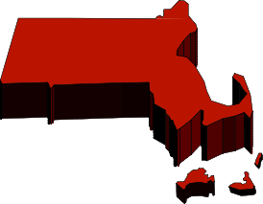
PARITY: |  | GAPS:
Private Insurance | F | Private Insurance  - MA is bordered by NH and VT which have private insurance parity laws. No telemedicine parity law despite a number of bills introduced in 2015 to achieve parity under private insurance, Medicaid and state employee plans.117  Medicaid  - Offers coverage under select managed care plans but not under FFS.118-­‐120  - Authorized to cover remote monitoring for home health agencies. Rules are in development  Innovation  - Received grant to establish a National Sexual Assault TeleNursing Center that will use telemedicine technology to provide 24/7, 365 day remote expert consultation by 24-­‐25 MA Sexual Assault Nurse Examiners (SANEs) to clinicians caring for adult and adolescent sexual assault patients in remote and/or underserved  regions of the United States.121  Partners Telestroke Network – members receive 24-­‐hour acute neurology/stroke expertise-­‐on-­‐ demand.122
Medicaid | B
State Employee Health Plan | F
MEDICAID SERVICE COVERAGE & CONDITIONS OF PAYMENT:
Patient Setting | A
Eligible Technologies | C
Distance or Geography Restrictions | A
Eligible Providers | A
Physician-­‐provided Services | A
Mental/behavioral Health Services | B
Rehabilitation | F
Home Health123 | F
Informed Consent | A
Telepresenter | A
INNOVATIVE PAYMENT OR SERVICE DELIVERY MODELS:
State-­‐wide Network | ✔
Medicaid Managed Care | ✔
Medicare-­‐Medicaid Dual Eligibles
Health Home
HCBS Waiver
Corrections
Other

Telemedicine in Michigan

PARITY: GAPS:

Private Insurance B
Medicaid127-­‐128 C
State Employee Health Plan F

MEDICAID SERVICE COVERAGE & CONDITIONS OF PAYMENT:
Patient Setting B
Eligible Technologies F

Private Insurance
  - Michigan’s private insurance parity law was enacted in 2012. MI is 1 of 3 states that cover interactive audio-­‐video only as a condition of their parity law.124

Medicaid
  - Coverage for interactive audio-­‐video only.
  - Eliminated distance requirements in 2013.

Distance or Geography Restrictions
- • Limits on covered services and patient settings, but the agency does not specify the types of

Eligible Providers C
Physician-­‐provided Services B
practitioners who are eligible distant site providers.

Mental/behavioral Health Services
- • The agency covers telepractice for speech-­‐ language and audiology services provided within
the School Based Services (SBS) program which is

Rehabilitation C
Home Health F
Informed Consent A
Telepresenter A

INNOVATIVE PAYMENT OR SERVICE DELIVERY MODELS:
now in effect.125

Innovation
  - CMS approved duals proposal includes coverage for telemedicine.126

State-­‐wide Network
Medicaid Managed Care ✔
Medicare-­‐Medicaid Dual ✔
Eligibles Health Home HCBS Waiver Corrections Other

Telemedicine in Minnesota

PARITY: GAPS:

Private Insurance A
Medicaid132-­‐133 B
State Employee Health Plan A

MEDICAID SERVICE COVERAGE & CONDITIONS OF PAYMENT:
Patient Setting B
Eligible Technologies B

Progress
  - Minnesota enacted a telemedicine parity law in 2015 for private insurers and state employee health plans, including dental and joint self insured plans.129

Medicaid
  - New policies included in the parity law impose attestation requirements before payment is

Distance or Geography Restrictions
- made for telemedicine.
  - Coverage for interactive audio-­‐video and store-­‐

Eligible Providers B
Physician-­‐provided Services B
and-­‐forward.
  - Distant site provider is limited to a menu set of

Mental/behavioral Health Services
- providers including OT, PT, and speech therapists, and audiologists. Providers are not

Rehabilitation134 A
Home Health135 C
Informed Consent A
Telepresenter B

INNOVATIVE PAYMENT OR SERVICE DELIVERY MODELS:
State-­‐wide Network Medicaid Managed Care
Medicare-­‐Medicaid Dual Eligibles
Health Home HCBS Waiver Corrections Other
required to be located in a medical facility.
  - Medicaid also places frequency limits on all covered telemedicine services.
  - MN Medicaid now covers dental and alcohol and substance abuse services via telemedicine under the physician services benefit.
  - Covers skilled nursing and cost of RPM equipment rental under home health benefit.
  - Telepresenter required on premises.

Innovation
Chemical Dependency Continuum of Care Pilot Project implemented in 2013 to improve access to treatment and recovery support for alcohol and drug abuse services.130-­‐131

Telemedicine in Mississippi

PARITY: GAPS:

Private Insurance A
Medicaid A
State Employee Health Plan A

MEDICAID SERVICE COVERAGE & CONDITIONS OF PAYMENT:
Patient Setting A
Eligible Technologies B

Progress
  - Mississippi’s parity law was enacted in 2013. The law requires parity for telemedicine under private insurance, state employee health plans, and public assistance.136 In 2014, lawmakers passed a law requiring insurance plans to cover and reimburse for services via store-­‐and-­‐forward as well as remote patient monitoring for chronic disease management.137

Distance or Geography Restrictions
A • Medicaid places no restrictions on the patient setting for telemedicine coverage, but will only

Eligible Providers A
Physician-­‐provided Services A
pay the originating site fee to a menu set of
facilities.138

Mental/behavioral Health Services

A Medicaid
- The law requires Medicaid to cover and

Rehabilitation N/A
Home Health A
Informed Consent B
Telepresenter A

INNOVATIVE PAYMENT OR SERVICE DELIVERY MODELS:
State-­‐wide Network Medicaid Managed Care
Medicare-­‐Medicaid Dual Eligibles
Health Home HCBS Waiver
Corrections ✔
Other
reimburse for services via telemedicine including store-­‐and-­‐forward and remote patient monitoring.
- CMS approved the agency’s SPA to limit the originating site fee payment to a provider’s office, outpatient hospitals, CAHs, RHCs, FQHCs, CMHCs, therapeutic group homes, IHS clinics, and school-­‐based clinics.139
- MS Medical Board requires unspecified method of obtaining patient’s informed consent.140

Telemedicine in Missouri |  |  | 
PARITY: |  | GAPS:
Private Insurance | A | Private Insurance  - MO’s private insurance parity law was enacted in 2013 and included coverage for state employee health plans.141  Medicaid  - Coverage for telemedicine under Medicaid is about average. The agency imposes restrictions on covered services and designates certain patient settings (excluding the home and school) and eligible distant site providers (physicians, advanced registered nurse practitioners, and psychologists as a condition of payment.  - Coverage for interactive audio-­‐video only.  - Requires written informed consent and telepresenter on premises.142  - A number of bills were introduced but failed passage in 2015. The bills would have expanded telehealth coverage in schools, home, as well as home RPM and store-­‐and-­‐forward.143  Innovation  - Missouri Telehealth Network offers clinical, educational, emergency and disaster preparedness, and technical assistance via telemedicine across the state.
Medicaid144 | C
State Employee Health Plan145 | A
MEDICAID SERVICE COVERAGE & CONDITIONS OF PAYMENT:
Patient Setting | C
Eligible Providers | F
Physician-­‐provided Services | A
Mental/behavioral Health Services146-­‐148 | F
Rehabilitation | B
Home Health | B
Informed Consent | F
Telepresenter | F
Eligible Providers | F
Physician-­‐provided Services | B
INNOVATIVE PAYMENT OR SERVICE DELIVERY MODELS:
State-­‐wide Network149 | ✔
Medicaid Managed Care
Medicare-­‐Medicaid Dual Eligibles
Health Home
HCBS Waiver
Corrections | ✔
Other

Telemedicine in Montana

PARITY: GAPS:

Private Insurance A
Medicaid151 C
State Employee Health Plan A

MEDICAID SERVICE COVERAGE & CONDITIONS OF PAYMENT:
Patient Setting A
Eligible Technologies F

Private Insurance
  - MT’s private insurance parity law was enacted in 2013 and includes coverage for state employee health plans.150

Medicaid
  - Coverage for telemedicine under Medicaid is about average. The agency imposes restrictions on covered services when provided by physicians

Distance or Geography Restrictions
A only.
- Coverage for interactive audio-­‐video only.

Eligible Providers F
Physician-­‐provided Services B
Mental/behavioral Health B
Services
Rehabilitation F
Home Health F
Informed Consent A
Telepresenter A

INNOVATIVE PAYMENT OR SERVICE DELIVERY MODELS:

State-­‐wide Network
Medicaid Managed Care ✔
Medicare-­‐Medicaid Dual Eligibles
Health Home HCBS Waiver Corrections Other

Telemedicine in Nebraska
PARITY: |  | GAPS:
Private Insurance | F | Progress  - 2015 legislation introduced to highlight telemedicine providers in health plan provider directories but no parity legislation.152  - CMS approved SPA expands Medicaid telehealth coverage to include store-­‐and-­‐forward, RPM, home health services, OT, PT, speech and audiology, podiatry and optometric services.153  Private Insurance  - Bordered by CO which has a parity law for private insurance. NE does not have a parity law.  - Private insurance and state-­‐employee plans require coverage of autism treatment via telemedicine.154  Innovation  Nebraska Statewide Telehealth Network is a state-­‐wide communications network that supports clinical, educational, and administrative services via telemedicine.155
Medicaid156-­‐158 | B
State Employee Health Plan | F
MEDICAID SERVICE COVERAGE & CONDITIONS OF PAYMENT:
Patient Setting | A
Eligible Technologies | B
Distance or Geography Restrictions | A
Eligible Providers | A
Physician-­‐provided Services159 | B
Mental/behavioral Health Services160 | B
Rehabilitation | A
Home Health | B
Informed Consent | F
Telepresenter | A
INNOVATIVE PAYMENT OR SERVICE DELIVERY MODELS:
State-­‐wide Network | ✔
Medicaid Managed Care | ✔
Medicare-­‐Medicaid Dual Eligibles
Health Home
HCBS Waiver
Corrections
Other

Telemedicine in Nevada

PARITY: GAPS:

Private Insurance A
Medicaid163 A
State Employee Health Plan A

MEDICAID SERVICE COVERAGE & CONDITIONS OF PAYMENT:
Patient Setting A
Eligible Technologies F

Progress
  - Nevada enacted a telemedicine parity law in 2015 which affects coverage under private insurance, Medicaid, and state employee health plans.161
  - Regulations were approved in 2014 to require coverage of telemedicine for injured employees as a condition of workers compensation.162

Distance or Geography Restrictions

A Medicaid
- Medicaid removed the rural only restriction and

Eligible Providers A
Physician-­‐provided Services B
now covers telemedicine state-­‐wide.
  - Medicaid also places frequency limits on some covered telemedicine services.

Mental/behavioral Health
Services
A • Some telemedicine services require at least 1 in-­‐
person visit.

Rehabilitation A
Home Health B
Informed Consent A
Telepresenter A

INNOVATIVE PAYMENT OR SERVICE DELIVERY MODELS:
  - Coverage for interactive audio-­‐video only.

State-­‐wide Network Medicaid Managed Care
Medicare-­‐Medicaid Dual Eligibles
Health Home HCBS Waiver
Corrections ✔
Other

Telemedicine in New Hampshire
PARITY: |  | GAPS:
Private Insurance | A | Private Insurance  - NH’s parity law was enacted in 2009 and includes coverage under state employee health plans.164  Medicaid  - NH enacted legislation that includes Medicaid telehealth coverage language similar to Medicare.165  - Offers coverage under select managed care plans but not under FFS.166-­‐167  - Coverage for interactive audio-­‐video only.
Medicaid | F
State Employee Health Plan | A
MEDICAID SERVICE COVERAGE & CONDITIONS OF PAYMENT:
Patient Setting | C
Eligible Technologies | F
Distance or Geography Restrictions | C
Eligible Providers | F
Physician-­‐provided Services | B
Mental/behavioral Health Services | B
Rehabilitation | F
Home Health | F
Informed Consent | A
Telepresenter | A
INNOVATIVE PAYMENT OR SERVICE DELIVERY MODELS:
State-­‐wide Network
Medicaid Managed Care | ✔
Medicare-­‐Medicaid Dual Eligibles
Health Home
HCBS Waiver
Corrections | ✔
Other

Telemedicine in New Jersey

PARITY: GAPS:

Private Insurance F
Medicaid171 C
State Employee Health Plan F

MEDICAID SERVICE COVERAGE & CONDITIONS OF PAYMENT:
Patient Setting F
Eligible Technologies F

Progress
  - NJ Individual Health Coverage and Small Employer Health Benefits Programs approved new language in 2015 to cover "telemedicine", "e-­‐visits", and "virtual visits" under individual health and small employer plans.168-­‐169

Private Insurance
  - No telemedicine parity law. 2015 legislation

Distance or Geography Restrictions
- introduced to provide parity under private insurance, managed care plans and state
170

Eligible Providers F
Physician-­‐provided Services B
employee plans.

Medicaid

Mental/behavioral Health
Services
- • Authorized coverage of telemedicine-­‐provided
services for the first time in December 2013.

Rehabilitation N/A
Home Health F
Informed Consent B
Telepresenter B

INNOVATIVE PAYMENT OR SERVICE DELIVERY MODELS:
State-­‐wide Network
Medicaid Managed Care ✔
Medicare-­‐Medicaid Dual Eligibles
Health Home HCBS Waiver Corrections Other
Coverage offered under managed care plans but not FFS.
- Coverage for telepsychiatry only by psychiatrist or psychiatric advance nurse practitioner.
- Patient setting must be a mental health clinic or outpatient hospital.
- Coverage for interactive audio-­‐video only. Medicaid requires telepresenter on premises and unspecified method of obtaining patient informed consent.

Telemedicine in New Mexico

PARITY: GAPS:

Private Insurance A
Medicaid174 A
State Employee Health Plan A

MEDICAID SERVICE COVERAGE & CONDITIONS OF PAYMENT:
Patient Setting A
Eligible Technologies C

Private Insurance
  - NM’s parity law was enacted in 2013.172

Medicaid
  - True parity under NM Medicaid for FFS and managed care plans. All services are covered via telemedicine including school-­‐based, dental, home health, hospice, and rehabilitation.173
  - 1 of 3 states with coverage for services provided

Distance or Geography Restrictions
A by a behavioral analyst. These specialists are critical for the treatment of autism spectrum

Eligible Providers A
Physician-­‐provided Services A
disorders.
  - No limits on patient setting.

Mental/behavioral Health Services175
A • No coverage for phone calls or remote patient monitoring.

Rehabilitation176 A
Home Health B
Informed Consent A
Telepresenter A

INNOVATIVE PAYMENT OR SERVICE DELIVERY MODELS:
State-­‐wide Network177 ✔
Medicaid Managed Care178-­‐179 ✔
Medicare-­‐Medicaid Dual Eligibles
Health Home HCBS Waiver
Corrections ✔
Other
  - No coverage for skilled nursing, therapies, or
RPM under home health benefit.

Innovation
New Mexico Telehealth Alliance offers technical and program support to ensure coordinated services via telemedicine across the state.

Telemedicine in New York

PARITY: GAPS:

Private Insurance C
Medicaid185 B
State Employee Health Plan F

MEDICAID SERVICE COVERAGE & CONDITIONS OF PAYMENT:
Patient Setting C
Eligible Technologies C

Progress
  - New York parity law enacted in 2014 and amended in 2015. The law requires telehealth parity under private insurance, Medicaid, and state employee health plans. The law does restrict the patient setting as a condition of payment.180-­‐181

Medicaid

Distance or Geography Restrictions
A • The new law authorizes Medicaid to cover telehealth via interactive audio-­‐video, store-­‐and-­‐

Eligible Providers F
forward, and home remote patient
182

Physician-­‐provided Services186 C
monitoring.

Mental/behavioral Health Services
- Restrictions are placed on the patient settings
C and types of providers eligible to render the
service and reimburse.

Rehabilitation F
Home Health F
Informed Consent A
Telepresenter A

INNOVATIVE PAYMENT OR SERVICE DELIVERY MODELS:
State-­‐wide Network
Medicaid Managed Care187 ✔
  - Speech language pathologist and audiologist are covered under the new law.

Innovation
  - CMS approved duals proposal includes coverage for telemedicine.183
CMS approved health home proposal gives provider the option to use technology conferencing tools including audio, video and/or web deployed solutions to support care

Medicare-­‐Medicaid Dual Eligibles
✔ management/coordination activities.184

Health Home ✔
HCBS Waiver Corrections Other

Telemedicine in North Carolina
PARITY: |  | GAPS:
Private Insurance | F | Private Insurance  - Bordered by GA and VA which have private insurance parity laws. No telemedicine parity law. Legislation introduced and failed passage in 2015 which would have establish telehealth parity for all health insurers in the state.188  Medicaid  - Medicaid imposes restrictions on the patient settings, covered services and designates eligible distant site providers as a condition of payment.  - Coverage for interactive audio-­‐video only, but does not permit the use of “video cell phones”.  - Requires a provider to be on the premises with the patient.  Innovation  - State-­‐wide telepsychiatry network.189
Medicaid190 | B
State Employee Health Plan | F
MEDICAID SERVICE COVERAGE & CONDITIONS OF PAYMENT:
Patient Setting | C
Eligible Technologies | F
Distance or Geography Restrictions | A
Eligible Providers | F
Physician-­‐provided Services | B
Mental/behavioral Health Services | B
Rehabilitation | N/A
Home Health | F
Informed Consent | A
Telepresenter | B
INNOVATIVE PAYMENT OR SERVICE DELIVERY MODELS:
State-­‐wide Network | ✔
Medicaid Managed Care
Medicare-­‐Medicaid Dual Eligibles
Health Home
HCBS Waiver
Corrections
Other

Telemedicine in North Dakota |  |  | 
PARITY: |  | GAPS:
Private Insurance | F | Progress  - HB 1038 was enacted in 2015 to establish telemedicine parity for state employee health plans.191  Private Insurance  - Bordered by MT which has a private insurance parity law. No telemedicine parity law for private insurance.  Medicaid  - Medicaid imposes restrictions on the patient settings and covered services as a condition of payment.  - Includes coverage for speech therapy.  - Coverage for interactive audio-­‐video and RPM under the home health benefit.192  Non-­‐home health services require a telepresenter.
Medicaid193 | B
State Employee Health Plan | A
MEDICAID SERVICE COVERAGE & CONDITIONS OF PAYMENT:
Patient Setting | F
Eligible Technologies | C
Distance or Geography Restrictions | A
Eligible Providers | A
Physician-­‐provided Services | B
Mental/behavioral Health Services | B
Rehabilitation | B
Home Health | F
Informed Consent | A
Telepresenter | C
INNOVATIVE PAYMENT OR SERVICE DELIVERY MODELS:
State-­‐wide Network
Medicaid Managed Care
Medicare-­‐Medicaid Dual Eligibles
Health Home
HCBS Waiver
Corrections
Other

Telemedicine in Ohio
PARITY: |  | GAPS:
Private Insurance | F | Private Insurance  - No telemedicine parity law. SB 32 introduced in 2015 to establish telehealth parity under private insurance and Medicaid.194  Medicaid  - New Medicaid regulations expand telemedicine coverage to include consultations by physicians and a limited selection of practitioners. The new rules also requires that the distant and originating site be at least 5 miles away.195-­‐196  - Coverage also includes school-­‐based speech therapy, behavioral health counseling and therapy, mental health assessment, pharmacological management, and community psychiatric supportive treatment service via interactive audio-­‐video only.197  - Medicaid allows beneficiaries to choose the patient location when telemedicine is used for some mental/behavioral health services.  - Requires written informed consent for mental and behavioral health services.  Innovation  - CMS approved health home proposal allows service delivery via in-­‐person, by telephone, or by video conferencing.198
Medicaid | C
State Employee Health Plan | F
MEDICAID SERVICE COVERAGE & CONDITIONS OF PAYMENT:
Patient Setting | C
Eligible Technologies | F
Distance or Geography Restrictions | B
Eligible Providers | C
Physician-­‐provided Services | B
Mental/behavioral Health Services | B
Rehabilitation | B
Home Health | F
Informed Consent | F
Telepresenter | A
INNOVATIVE PAYMENT OR SERVICE DELIVERY MODELS:
State-­‐wide Network
Medicaid Managed Care | ✔
Medicare-­‐Medicaid Dual Eligibles
Health Home | ✔
HCBS Waiver
Corrections | ✔
Other

Telemedicine in Oklahoma

PARITY: GAPS:

Private Insurance A
Medicaid A
State Employee Health Plan A

MEDICAID SERVICE COVERAGE & CONDITIONS OF PAYMENT:
Patient Setting A
Eligible Technologies F

Progress
  - Medicaid regulations updated in 2015 which removed the originating site and geography restrictions as well as expanded coverage to include other services.199

Private Insurance
  - OK’s private insurance parity law was enacted in 1997.200

Distance or Geography Restrictions
A

Medicaid

Eligible Providers A
Physician-­‐provided Services A
  - Coverage for interactive audio-­‐video only.
  - Medicaid requires written informed consent from patient before a telemedicine encounter

Mental/behavioral Health
Services
A and a telepresenter.

Rehabilitation N/A
Home Health F
Informed Consent F
Telepresenter C

INNOVATIVE PAYMENT OR SERVICE DELIVERY MODELS:

State-­‐wide Network
Medicaid Managed Care ✔
Medicare-­‐Medicaid Dual Eligibles
Health Home HCBS Waiver
Corrections ✔
Other

Telemedicine in Oregon |  |  | 
PARITY: |  | GAPS:
Private Insurance | B | Progress  - 2015 legislation enacted to include telemedicine parity for self-­‐insured state employee health plans and remove originating site restrictions from existing parity law.201  Private Insurance  - Oregon’s private insurance parity law was enacted in 2009. OR is 1 of 3 states that cover interactive audio-­‐video only as a condition of their parity law.202  Medicaid  - Medicaid imposes restrictions on the covered services.  Allows coverage for interactive audio-­‐video, telephone, and online/e-­‐mail consultations. Medicaid will also cover store-­‐and-­‐forward when used in lieu of video conferencing.
Medicaid203 | B
State Employee Health Plan | B
MEDICAID SERVICE COVERAGE & CONDITIONS OF PAYMENT:
Patient Setting | A
Eligible Technologies | C
Distance or Geography Restrictions | A
Eligible Providers | A
Physician-­‐provided Services | B
Mental/behavioral Health Services | B
Rehabilitation | F
Home Health | F
Informed Consent | A
Telepresenter | A
INNOVATIVE PAYMENT OR SERVICE DELIVERY MODELS:
State-­‐wide Network
Medicaid Managed Care
Medicare-­‐Medicaid Dual Eligibles
Health Home
HCBS Waiver
Corrections
Other

Telemedicine in Pennsylvania
PARITY: |  | GAPS:
Private Insurance | F | Private Insurance  - Bordered by MD and NY which have private insurance parity laws. 2015 legislation introduced to establish telemedicine parity for private insurance.204  Medicaid  - Medicaid imposes restrictions on the covered services and designates eligible distant site providers as a condition of payment.  - PA offers a number of telemedicine modalities in the home of qualified beneficiaries including sensors, medication management, and RPM under a CMS HCBS waiver. This waiver expires in 2018.205  - Coverage for interactive audio-­‐video only for physician and mental health services.  - Requires written informed consent and a telepresenter.
Medicaid206 | B
State Employee Health Plan | F
MEDICAID SERVICE COVERAGE & CONDITIONS OF PAYMENT:
Patient Setting | A
Eligible Technologies | C
Distance or Geography Restrictions | A
Eligible Providers | F
Physician-­‐provided Services207 | B
Mental/behavioral Health Services | B
Rehabilitation | N/A
Home Health | C
Informed Consent | B
Telepresenter | C
INNOVATIVE PAYMENT OR SERVICE DELIVERY MODELS:
State-­‐wide Network
Medicaid Managed Care | ✔
Medicare-­‐Medicaid Dual Eligibles
Health Home
HCBS Waiver | ✔
Corrections
Other

Telemedicine in Rhode Island |  |  | 
PARITY: |  | GAPS:
Private Insurance | F | Private Insurance  - No telemedicine parity law despite a multi-­‐year effort to introduce legislation regarding coverage under private insurance and Medicaid.208  Medicaid  No coverage for telemedicine under Medicaid plans.
Medicaid | F
State Employee Health Plan | F
MEDICAID SERVICE COVERAGE & CONDITIONS OF PAYMENT:
Patient Setting | F
Eligible Technologies | F
Distance or Geography Restrictions | F
Eligible Providers | F
Physician-­‐provided Services | F
Mental/behavioral Health Services | F
Rehabilitation | N/A
Home Health | F
Informed Consent | N/A
Telepresenter | N/A
INNOVATIVE PAYMENT OR SERVICE DELIVERY MODELS:
State-­‐wide Network
Medicaid Managed Care
Medicare-­‐Medicaid Dual Eligibles
Health Home
HCBS Waiver
Corrections
Other

Telemedicine in South Carolina

PARITY: GAPS:

Private Insurance F
Medicaid212 C
State Employee Health Plan F

MEDICAID SERVICE COVERAGE & CONDITIONS OF PAYMENT:
Patient Setting C
Eligible Technologies C

Private Insurance
  - Bordered by GA which has a parity law. No telemedicine parity legislation introduced in 2015.

Medicaid
  - Medicaid imposes restrictions on the covered services, patient settings and designates eligible distant site providers as a condition of payment.

Distance or Geography Restrictions
- • Coverage for interactive audio-­‐video only and RPM for chronic disease management in the

Eligible Providers F
home under their HCBS waiver. This waiver
209

Physician-­‐provided Services B
expires in 2016.
  - Medicaid requires a telepresenter for all audio-­‐

Mental/behavioral Health
Services
- video related telemedicine encounters.

Rehabilitation N/A
Home Health F
Informed Consent A
Telepresenter C

INNOVATIVE PAYMENT OR SERVICE DELIVERY MODELS:
State-­‐wide Network ✔
Medicaid Managed Care Medicare-­‐Medicaid Dual Eligibles
Health Home
HCBS Waiver ✔
Corrections
Other ✔

Innovation
- State-­‐wide telepsychiatry network.210
OB/GYN Telemedicine demonstration project went into effect in July 2014. The project will leverage telemedicine to enhance access to obstetric and gynecological services for women in four rural counties.211

Telemedicine in South Dakota

PARITY: GAPS:

Private Insurance F
Medicaid214 C
State Employee Health Plan F

MEDICAID SERVICE COVERAGE & CONDITIONS OF PAYMENT:
Patient Setting C
Eligible Technologies B

Private Insurance
  - Bordered by MT which has a parity law. No history of proposed legislation within the past 2 years.

Medicaid
  - Coverage for telemedicine under Medicaid is above average. The agency imposes restrictions on the patient settings, covered services and

Distance or Geography Restrictions
- designates eligible distant site providers as a condition of payment.

Eligible Providers A
Physician-­‐provided Services B
  - SD Medicaid no longer includes phone calls and
store-­‐and-­‐forward under its telemedicine definition. Coverage for interactive audio-­‐video

Mental/behavioral Health
Services
- and RPM only.

Rehabilitation F
Home Health215 F
Informed Consent A
Telepresenter A

INNOVATIVE PAYMENT OR SERVICE DELIVERY MODELS:

Innovation
  - Received grant from US Bureau of Justice Assistance to implement a telehealth drug treatment program for nonviolent offenders.213

State-­‐wide Network Medicaid Managed Care
Medicare-­‐Medicaid Dual Eligibles
Health Home HCBS Waiver
Corrections ✔
Other ✔

Telemedicine in Tennessee |  |  | 
PARITY: |  | GAPS:
Private Insurance | A | Progress  - TN parity law enacted in 2014 which includes telemedicine coverage for Medicaid, including managed care plans, and state employee health plans.216  Medicaid  - Parity law goes into effect 2015. It does limit coverage to specific patient settings and includes telemedicine when provided to schools and the home under the home health benefit. Most of the state’s Medicaid program operates under managed care.  - Home health does not include coverage for RPM under new parity law.  - Coverage for interactive audio-­‐video and store-­‐ and-­‐forward.
Medicaid | B
State Employee Health Plan | A
MEDICAID SERVICE COVERAGE & CONDITIONS OF PAYMENT:
Patient Setting | A
Eligible Technologies | C
Distance or Geography Restrictions | A
Eligible Providers | A
Physician-­‐provided Services | A
Mental/behavioral Health Services | A
Rehabilitation | A
Home Health | B
Informed Consent | A
Telepresenter | A
INNOVATIVE PAYMENT OR SERVICE DELIVERY MODELS:
State-­‐wide Network
Medicaid Managed Care | ✔
Medicare-­‐Medicaid Dual Eligibles
Health Home
HCBS Waiver
Corrections | ✔
Other

Telemedicine in Texas

PARITY: GAPS:

Private Insurance A
Medicaid219 B
State Employee Health Plan A

MEDICAID SERVICE COVERAGE & CONDITIONS OF PAYMENT:
Patient Setting A
Eligible Technologies B

Progress
  - Legislation enacted that recognizes schools as an originating site for telemedicine covered services under Medicaid.217

Private Insurance
  - TX private insurance parity law enacted in 1997 and also includes coverage for state employee health plans.218

Distance or Geography Restrictions
A

Medicaid

Eligible Providers C
Physician-­‐provided Services B
  - Two distinct definitions of telemedicine vs.
telehealth.
  - Originating site includes established medical

Mental/behavioral Health
Services
B health site and state mental health facility, which
excludes the home.

Rehabilitation F
Home Health220 F
Informed Consent B
Telepresenter C

INNOVATIVE PAYMENT OR SERVICE DELIVERY MODELS:
State-­‐wide Network Medicaid Managed Care
Medicare-­‐Medicaid Dual Eligibles
Health Home HCBS Waiver
Corrections ✔
Other
  - Patients must receive an in-­‐person evaluation for the same diagnosis or condition being rendered via telemedicine. Patients with mental health diagnoses or conditions are exempt from this requirement if the purpose of telemedicine is to screen and refer for additional services. In order to continue receiving telemedicine services, the patient must have an in-­‐person evaluation at least once within the 12 months before receiving telemedicine.
  - Coverage for interactive audio-­‐video only as well as RPM for home health agencies and hospitals. Requires written informed consent and a telepresenter during the telemedicine encounter.

Telemedicine in Utah
PARITY: |  | GAPS:
Private Insurance | F | Progress  - Medicaid issued a notice in 2015 clarifying CMS guidance on telemedicine coverage. UT will cover physician and NP services delivered via telemedicine. However non-­‐medical mental and behavioral health providers are not included in this coverage.221  Private Insurance  - Bordered by AZ and CO which have parity laws for private insurance. UT has no history of proposed parity legislation within the past 2 years.  Medicaid  - No restrictions imposed on patient or provider settings  - Coverage for skilled nursing services and medication management under the skilled nursing home telemedicine pilot.222-­‐223  - Coverage for interactive audio-­‐video only.  Innovation  - Utah Telehealth Network offers clinical, educational, and administrative services via telemedicine across the state.224
Medicaid225 | C
State Employee Health Plan | F
MEDICAID SERVICE COVERAGE & CONDITIONS OF PAYMENT:
Patient Setting | A
Eligible Technologies | F
Distance or Geography Restrictions | A
Eligible Providers | F
Physician-­‐provided Services | A
Mental/behavioral Health Services226 | B
Rehabilitation | F
Home Health | C
Informed Consent | A
Telepresenter | A
INNOVATIVE PAYMENT OR SERVICE DELIVERY MODELS:
State-­‐wide Network | ✔
Medicaid Managed Care
Medicare-­‐Medicaid Dual Eligibles
Health Home
HCBS Waiver
Corrections
Other

Telemedicine in Vermont

PARITY: GAPS:

Private Insurance C
Medicaid229 B
State Employee Health Plan C

MEDICAID SERVICE COVERAGE &

Progress
  - 2015 Legislation enacted which removes facility restrictions from Medicaid coverage of telemedicine-­‐provided services. New law also allows coverage of telemedicine primary care
227

CONDITIONS OF PAYMENT:
Patient Setting A
Eligible Technologies C
services in the home.

Private Insurance
  - VT’s parity law was enacted in 2012. It includes

Distance or Geography Restrictions
A telemedicine coverage for state employee health plans.228

Eligible Providers A
Physician-­‐provided Services B
  - VT is 1 of 3 states that cover interactive audio-­‐
video only as a condition of their parity law.
  - Although the law does not require coverage of

Mental/behavioral Health
Services
A services via store-­‐and-­‐forward, it does require
informed consent from any patient receiving

Rehabilitation A
Home Health F
Informed Consent B
Telepresenter A

INNOVATIVE PAYMENT OR SERVICE DELIVERY MODELS:
State-­‐wide Network Medicaid Managed Care
Medicare-­‐Medicaid Dual Eligibles
Health Home HCBS Waiver
Corrections ✔
Other
teledermatology and teleophthalmology via store-­‐and-­‐forward.
  - The parity law also limits telemedicine coverage to services provided in health care facilities only.

Medicaid
  - Coverage for interactive audio-­‐video and home RPM.

Telemedicine in Virginia |  |  | 
PARITY: |  | GAPS:
Private Insurance | A | Private Insurance  - VA’s parity law was enacted in 2010 and includes coverage for telemedicine under private insurance and self-­‐funded state employee health plans.230  Medicaid  - Coverage for telemedicine under Medicaid extends to managed care plans as well. The agency imposes restrictions on the patient setting.  - Medicaid restrictions on covered services and designates eligible distant site providers as a condition of payment. However Virginia is 1 of 3 states that includes specific coverage of obstetric and gynecological services including ultrasounds.231  - Covers speech-­‐language therapy under its school-­‐based program.232-­‐234  - Coverage for interactive audio-­‐video and store-­‐ an-­‐forward for diabetic retinopathy and dermatological services.  Innovation  - CMS approved VA plan to waive Medicare telemedicine statutory restrictions (1834m) for dual eligible population (Commonwealth Coordinated Care).
Medicaid235 | B
State Employee Health Plan | A
MEDICAID SERVICE COVERAGE & CONDITIONS OF PAYMENT:
Patient Setting | C
Eligible Technologies | C
Distance or Geography Restrictions | A
Eligible Providers | C
Physician-­‐provided Services236-­‐  237 | B
Mental/behavioral Health Services | B
Rehabilitation | B
Home Health | F
Informed Consent | B
Telepresenter | A
INNOVATIVE PAYMENT OR SERVICE DELIVERY MODELS:
State-­‐wide Network238 | ✔
Medicaid Managed Care239 | ✔
Medicare-­‐Medicaid Dual Eligibles240 | ✔
Health Home
HCBS Waiver
Corrections241 | ✔
Other

Telemedicine in Washington

PARITY: GAPS:

Private Insurance A
Medicaid246 A
State Employee Health Plan A

MEDICAID SERVICE COVERAGE & CONDITIONS OF PAYMENT:
Patient Setting B
Eligible Technologies C

Progress
  - Washington’s parity law was enacted in 2015 and provides coverage for all essential health benefits offered by private insurance, state employee health plans, and Medicaid managed care.242

Medicaid
  - The new parity law which goes into effect 2017 will impact Medicaid managed care and not FFS

Distance or Geography Restrictions
- plan offerings.
  - New SPA approved by CMS adds the home and

Eligible Providers C
Physician-­‐provided Services B
school to list of eligible originating sites. It also
expands the list of providers who may render services including dentists and a number of

Mental/behavioral Health
Services
- mental and behavioral health providers. The
Medicaid program manual has not been updated

Rehabilitation F
Home Health247 C
Informed Consent F
Telepresenter A

INNOVATIVE PAYMENT OR SERVICE DELIVERY MODELS:
State-­‐wide Network
Medicaid Managed Care ✔
Medicare-­‐Medicaid Dual Eligibles
Health Home HCBS Waiver Corrections Other
to reflect this emergency rulemaking.243
  - Medicaid restrictions on covered services and designates eligible distant site providers as a condition of payment. However Washington is 1 of 3 states that covers services provided by behavioral analysts which are critical to the treatment of autism spectrum disorders. The regulations were amended earlier this year to allow this expansion.244
  - Coverage for interactive audio-­‐video as and RPM under the home health benefit.245
Written informed consent required.

Telemedicine in West Virginia

PARITY: GAPS:

Private Insurance F
Medicaid248 F
State Employee Health Plan F

MEDICAID SERVICE COVERAGE & CONDITIONS OF PAYMENT:
Patient Setting C
Eligible Technologies F

Private Insurance
  - WV is bordered by two states with private insurance parity laws: Kentucky and Virginia. No parity legislation introduced in 2015.

Medicaid
  - Coverage is limited to originating sites located in non-­‐metropolitan professional shortage areas for services listed under the physician benefit. This

Distance or Geography Restrictions
- restriction does not apply to telemedicine services provided under the mental and

Eligible Providers C
Physician-­‐provided Services B
behavioral health benefit. In fact WV Medicaid
encourages providers to use telemedicine to enhance access to mental and behavioral health

Mental/behavioral Health
Services249-­‐250
A services.
- Coverage for interactive audio-­‐video only.

Rehabilitation F
Home Health F
Informed Consent B
Telepresenter B

INNOVATIVE PAYMENT OR SERVICE DELIVERY MODELS:
State-­‐wide Network
Medicaid Managed Care251 ✔
Medicare-­‐Medicaid Dual Eligibles
Health Home252 HCBS Waiver Corrections Other
  - Managed care plan covers weight management services including preventative medicine counseling and individual and group exercise classes with nutritional counseling. Only state to allow exercise physiologists and certified trainers as eligible distant site providers.
Requires telepresenter on patient site premises and unspecified form of consent only for behavioral health services.

Telemedicine in Wisconsin
PARITY: |  | GAPS:
Private Insurance | F | Private Insurance  - No telemedicine parity law and no history of proposed legislation within the past 2 years.  Medicaid  - Coverage for telemedicine under Medicaid includes fee-­‐for-­‐service and managed care plans. The agency imposes no restrictions on the patient setting or originating site and defers to the universal place of service (POS) used by most payors. This list includes the home and schools.  - Medicaid imposes restrictions on covered services and designates eligible distant site providers as a condition of payment.  - Medicaid requires informed consent from the patient but does not specify how the consent should be obtained.  - Coverage for interactive audio-­‐video only.
Medicaid253 | B
State Employee Health Plan | F
MEDICAID SERVICE COVERAGE & CONDITIONS OF PAYMENT:
Patient Setting | A
Eligible Technologies | F
Distance or Geography Restrictions | A
Eligible Providers | F
Physician-­‐provided Services | B
Mental/behavioral Health Services | B
Rehabilitation | F
Home Health | F
Informed Consent | B
Telepresenter | A
INNOVATIVE PAYMENT OR SERVICE DELIVERY MODELS:
State-­‐wide Network
Medicaid Managed Care | ✔
Medicare-­‐Medicaid Dual Eligibles
Health Home
HCBS Waiver
Corrections
Other

Telemedicine in Wyoming |  |  | 
PARITY: |  | GAPS:
Private Insurance | F | Private Insurance  - No telemedicine parity law and no history of proposed legislation within the past 2 years.  Medicaid  - Coverage for telemedicine under Medicaid is about average. The agency imposes restrictions on covered services and designates certain patient settings (excluding the home and school) and eligible distant site providers as a condition of payment.  - One of few states with coverage for services provided by substance abuse/addiction specialist.  - Covers nutrition patient education and speech therapy.  - Coverage for interactive audio-­‐video only.  - No coverage for telemedicine under the home health benefit.  Innovation  Wyoming Telehealth Consortium offers provider registry and informational resources to assist providers in adopting telemedicine.
Medicaid254 | C
State Employee Health Plan | F
MEDICAID SERVICE COVERAGE & CONDITIONS OF PAYMENT:
Patient Setting | C
Eligible Technologies | F
Distance or Geography Restrictions | A
Eligible Providers | C
Physician-­‐provided Services | B
Mental/behavioral Health Services | B
Rehabilitation | B
Home Health | F
Informed Consent | A
Telepresenter | A
INNOVATIVE PAYMENT OR SERVICE DELIVERY MODELS:
State-­‐wide Network255 | ✔
Medicaid Managed Care
Medicare-­‐Medicaid Dual Eligibles
Health Home
HCBS Waiver
Corrections
Other

Appendix

State Ratings – Parity Laws for Private Insurance Coverage of Telemedicine

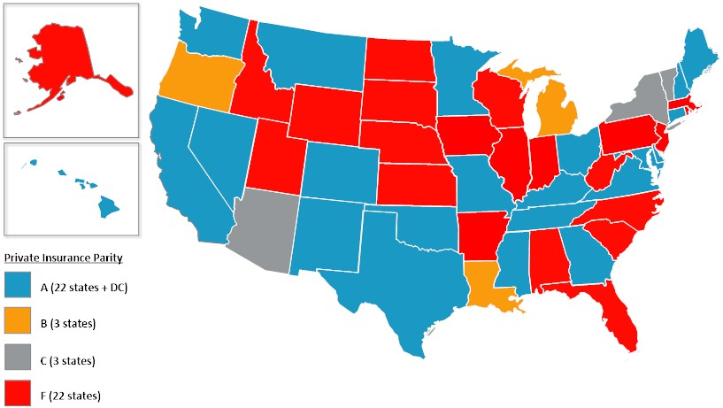

State Ratings – Medicaid Policies for Telemedicine Coverage

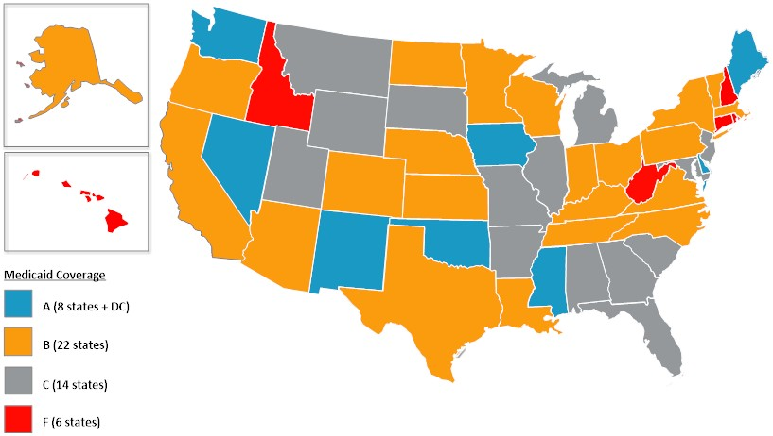

State Ratings – State Employee Health Plan Laws for Telemedicine Coverage

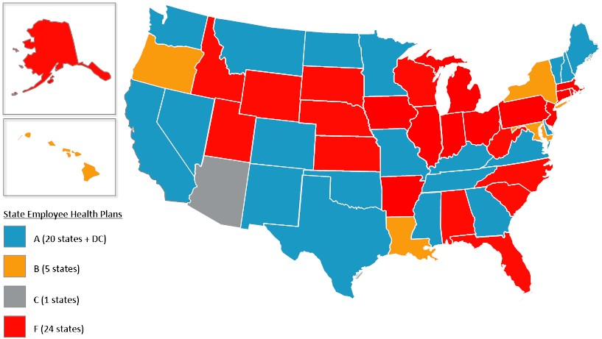

State Ratings – Medicaid Patient Setting

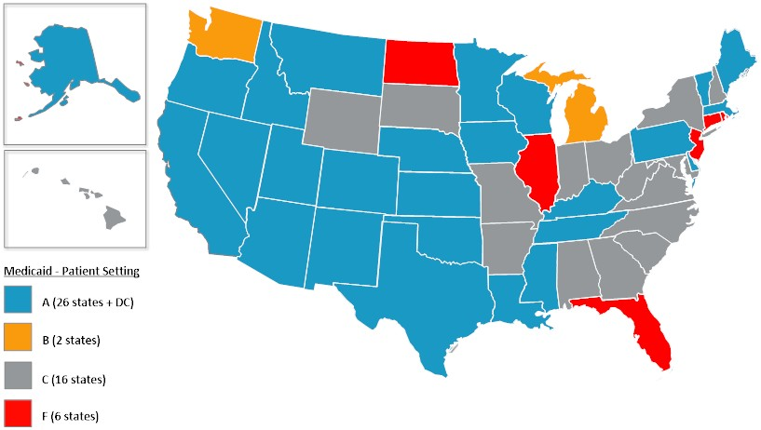

State Ratings – Medicaid Eligible Technologies

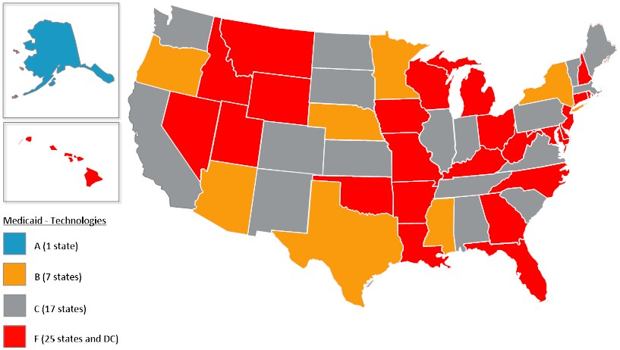

State Ratings – Medicaid Distance or Geography Restrictions

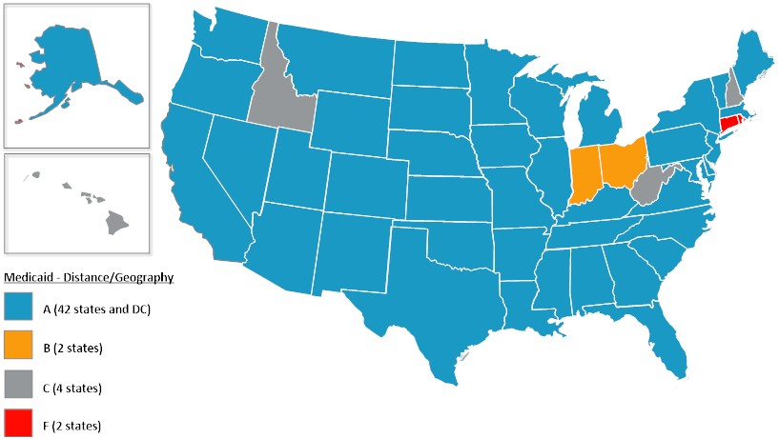

State Ratings – Medicaid Eligible Providers

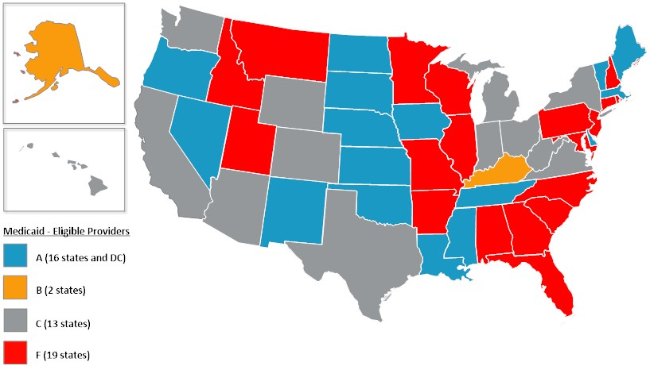

State Ratings – Medicaid Physician-­‐provided Telemedicine Services

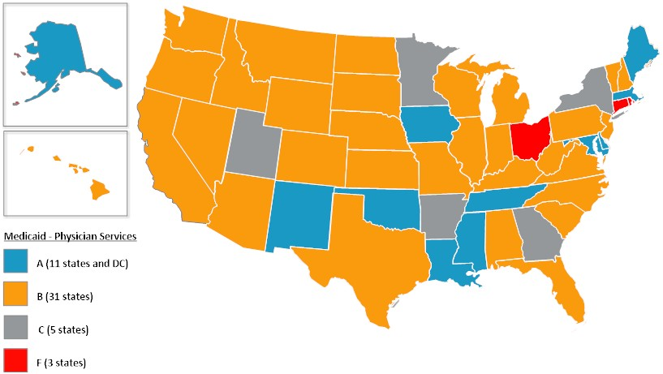

State Ratings – Medicaid Mental and Behavioral Health Services

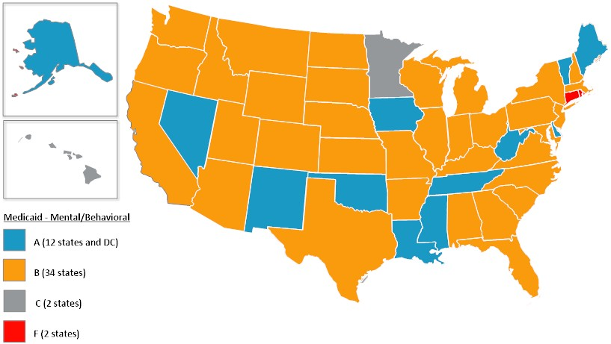

State Ratings – Medicaid Rehabilitation Services

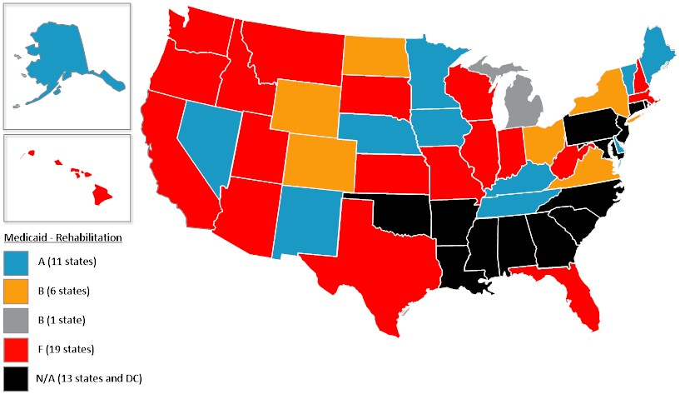

State Ratings – Medicaid Home Health Services

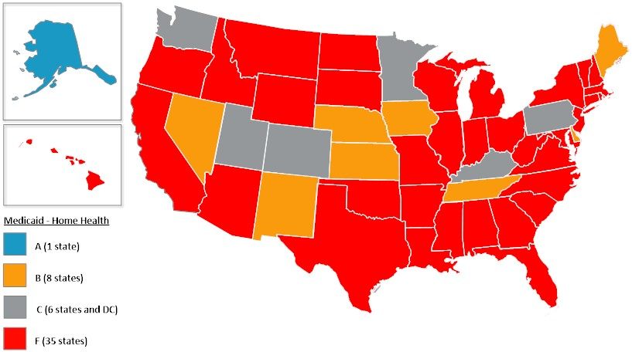

State Ratings – Medicaid Informed Consent

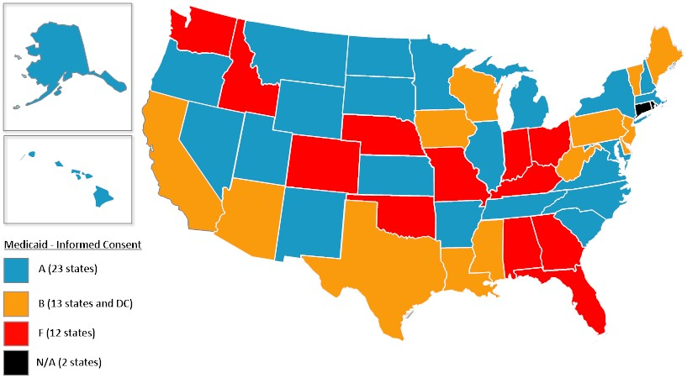

State Ratings – Medicaid Telepresenter

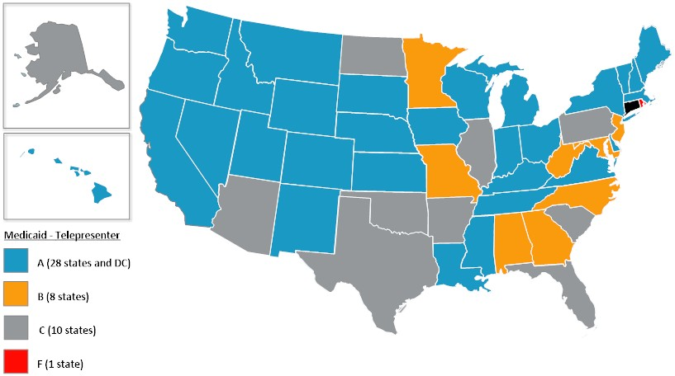

References

1 Thomas, L. & Capistrant, G. American Telemedicine Association. “State Telemedicine Gaps Analysis” September 2014.
2 ATA State Policy Toolkit, 2015.
3 215 ILCS 5/356z.22; http://www.ilga.gov/legislation/ilcs/documents/021500050K356z.22.htm
4 MCL Ch. 175 section 47BB; https://malegislature.gov/Laws/GeneralLaws/PartI/TitleXXII/Chapter175/Section47BB
5 Medicaid Benefits -­‐ Physical Therapy and Other Services. Kaiser Family Foundation. 2012.
6 CMS tests models with States to better align the financing of Medicare and Medicaid programs and integrate primary, acute, behavioral health and long-­‐term services and supports for their Medicare-­‐Medicaid enrollees. For the Capitated Model, a state, CMS, and a health plan enter into a three-­‐way contract, and the plan receives a
prospective blended payment to provide comprehensive, coordinated care; http://www.cms.gov/Medicare-­‐ Medicaid-­‐Coordination/Medicare-­‐and-­‐Medicaid-­‐Coordination/Medicare-­‐Medicaid-­‐Coordination-­‐ Office/FinancialAlignmentInitiative/CapitatedModel.html
7 Medicaid.gov, 2015; https://www.medicaid.gov/state-­‐resource-­‐center/medicaid-­‐state-­‐technical-­‐ assistance/health-­‐homes-­‐technical-­‐assistance/downloads/hh-­‐map_v51.pdf
8 Medicaid.gov, 2015; http://www.medicaid.gov/Medicaid-­‐CHIP-­‐Program-­‐Information/By-­‐Topics/Waivers/Home-­‐ and-­‐Community-­‐Based-­‐1915-­‐c-­‐Waivers.html
9 AL Medicaid Management Information System Provider Manual, Chapter–28 Physicians, p. 17;
http://medicaid.alabama.gov/CONTENT/6.0_Providers/6.7_Manuals/6.7.1_Provider_Manuals_2015/6.7.1.2_April_ 2015.aspx
10 AL Medicaid Management Information System Provider Manual, Chapter–105 Rehabilitative Services: DHR, DYS,
DPH, DMH, p. 11;
http://medicaid.alabama.gov/documents/6.0_Providers/6.7_Manuals/6.7.1_Provider_Manuals_2015/6.7.1.2_Apri l_2015/Apr15_105.pdf
11 AL Medicaid Management Information System Provider Manual, Chapter–39 Patient 1st Billing Manual, p. 32;
http://medicaid.alabama.gov/documents/6.0_Providers/6.7_Manuals/6.7.1_Provider_Manuals_2015/6.7.1.2_Apri l_2015/Apr15_39.pdf
12 AL Medicaid Agency, Amendment to Alabama State Plan for Medical Assistance (PN-­‐11-­‐10), May 2011;
http://www.alabamaadministrativecode.state.al.us/UpdatedMonthly/AAM-­‐MAY-­‐11/MISC.PDF
13 AL Medicaid Patient 1st In-­‐Home Monitoring Program; January 2011;
http://medicaid.alabama.gov/documents/4.0_Programs/4.4_Medical_Services/4.4.10_Patient_1st/4.4.10_In_Hom e_Monitoring_Revised_1-­‐24-­‐11.pdf
14 Alaska Medical Assistance Provider Billing Manual, Section II–School-­‐Based Services, Policies and Procedures;
http://manuals.medicaidalaska.com/sbs/sbs.htm
15 Alaska Medical Assistance Provider Billing Manual, Section I: Physician, Advanced Nurse Practitioner & Physician Assistant Services; http://manuals.medicaidalaska.com/physician/physician.htm
16 Alaska Medical Assistance Provider Billing Manual, Section II–Podiatry Services, Policies and Procedures; http://manuals.medicaidalaska.com/podiatry/podiatry.htm
17 Alaska Medical Assistance Provider Billing Manual, Section II–Early and Periodic Screening, Diagnosis and
Treatment Services, Policies and Procedures; http://manuals.medicaidalaska.com/epsdt/epsdt.htm
18 Alaska Medical Assistance Provider Billing Manual, Section II–Tribal Facility Services, Policies and Procedures; http://manuals.medicaidalaska.com/tribal/tribal.htm
19 Alaska Medical Assistance Provider Billing Manual, Section II–Hospice Services, Policies and Procedures; http://manuals.medicaidalaska.com/docs/dnld/BillingManual_Hospice.pdf
20 Alaska Medical Assistance Provider Billing Manual, Section II–Nutrition Services, Policies and Procedures;
http://manuals.medicaidalaska.com/docs/dnld/BillingManual_Nutrition.pdf
21 Alaska Medical Assistance Provider Billing Manual, Section II–Chiropractor Services, Policies and Procedures; http://manuals.medicaidalaska.com/docs/dnld/BillingManual_Chiropractic.pdf

22 Alaska Medical Assistance Provider Billing Manual, Section II–Community Behavioral Health Services, Policies and Procedures; http://manuals.medicaidalaska.com/cbhs/cbhs.htm
23 American Telemedicine Association, State Medicaid Best Practice: Telemental and Behavioral Health. August
2013; http://www.americantelemed.org/docs/default-­‐source/policy/ata-­‐best-­‐practice-­‐-­‐-­‐telemental-­‐and-­‐ behavioral-­‐health.pdf?sfvrsn=10
24 Alaska Medical Assistance Provider Billing Manual, Section II–Therapy Services, Policies and Procedures;
http://manuals.medicaidalaska.com/therapies/therapies.htm
25 Alaska Medical Assistance Provider Billing Manual, Section II–Home Health Services, Policies and Procedures; http://manuals.medicaidalaska.com/docs/dnld/BillingManual_HomeHealth.pdf
26 ARS 20-­‐841.09; http://www.azleg.gov/FormatDocument.asp?inDoc=/ars/20/00841-­‐
09.htm&Title=20&DocType=ARS
27 AZ Health Care Cost Containment System, AHCCCS Fee-­‐For-­‐Service Provider Manual, Chapter–10 Professional
and Technical Services, p. 41; http://www.azahcccs.gov/commercial/Downloads/FFSProviderManual/FFS_Chap10.pdf
28 AHCCCS Telehealth Training Manual; http://www.azahcccs.gov/commercial/Downloads/IHS-­‐
TribalManual/IHSTelehealthTrainingManual.pdf
29 American Telemedicine Association, State Medicaid Best Practice: Store and Forward Telemedicine. July 2013; http://www.americantelemed.org/docs/default-­‐source/policy/state-­‐medicaid-­‐best-­‐practice-­‐-­‐-­‐store-­‐and-­‐forward-­‐ telemedicine.pdf?sfvrsn=10
30 American Telemedicine Association, State Medicaid Best Practice: Telestroke. January 2014;
http://www.americantelemed.org/docs/default-­‐source/policy/state-­‐medicaid-­‐best-­‐practice-­‐-­‐-­‐ telestroke.pdf?sfvrsn=8
31 Arizona Telemedicine Program; http://telemedicine.arizona.edu/
32 AHCCCS Medical Policy Manual, Chapter 300-­‐Medical Policy for Covered Services, p.21; http://www.azahcccs.gov/shared/Downloads/MedicalPolicyManual/Chap300.pdf
33 Arkansas Medicaid, Physician/Independent lab/CRNA/Radiation Therapy Center-­‐Section II, p. 34; https://www.medicaid.state.ar.us/Download/provider/provdocs/Manuals/PHYSICN/PHYSICN_II.doc
34 Arkansas Medicaid, Rehabilitative Services for Persons with Mental Illness-­‐Section II, p. 14; https://www.medicaid.state.ar.us/InternetSolution/Provider/docs/rspmi.aspx
35 University of Arkansas for Medical Sciences – ANGELS Program; http://angels.uams.edu/
36 American Telemedicine Association, State Medicaid Best Practice: Telehealth for High-­‐risk Pregnancy. January 2014; http://www.americantelemed.org/docs/default-­‐source/policy/state-­‐medicaid-­‐best-­‐practice-­‐-­‐-­‐telehealth-­‐for-­‐ high-­‐risk-­‐pregnancy.pdf?sfvrsn=6
37 CA Insurance Code Sec. 10110 -­‐ 10127.19; http://leginfo.legislature.ca.gov/faces/codes_displaySection.xhtml?lawCode=INS&sectionNum=10123.85 38 AB 1310; http://www.leginfo.ca.gov/cgi-­‐bin/postquery?bill_number=ab_1310&sess=1314&house=A 39 AB 1771; http://www.leginfo.ca.gov/cgi-­‐bin/postquery?bill_number=ab_1771&sess=1314&house=A 40 AB 1174; http://www.leginfo.ca.gov/cgi-­‐bin/postquery?bill_number=ab_1174&sess=1314&house=A
41 CA Department of Health Care Services, Medi-­‐Cal Part 2 General Medicine Manual, Telehealth, http://files.medi-­‐ cal.ca.govpublications/masters-­‐mtp/part2/mednetele_m01o03.doc
42 Department of Health Care Services (DHCS), Telehealth Billing Recorded Webinar, September 2013.
43 CA Welfare and Institutions Code Sec. 14132.72; http://leginfo.legislature.ca.gov/faces/codes_displaySection.xhtml?lawCode=WIC&sectionNum=14132.72. 44 CA Welfare and Institutions Code Sec. 14132.725;
http://leginfo.legislature.ca.gov/faces/codes_displaySection.xhtml?lawCode=WIC&sectionNum=14132.725.
45 American Telemedicine Association, State Medicaid Best Practice: Store and Forward Telemedicine. July 2013;
http://www.americantelemed.org/docs/default-­‐source/policy/state-­‐medicaid-­‐best-­‐practice-­‐-­‐-­‐store-­‐and-­‐forward-­‐ telemedicine.pdf?sfvrsn=10

46 American Telemedicine Association, State Medicaid Best Practice: Telemental and Behavioral Health. August 2013; http://www.americantelemed.org/docs/default-­‐source/policy/ata-­‐best-­‐practice-­‐-­‐-­‐telemental-­‐and-­‐ behavioral-­‐health.pdf?sfvrsn=10
47 California Telehealth Network; http://www.caltelehealth.org/
48 CO Revised Statutes 10-­‐16-­‐123
49 10 CCR 2505-­‐10.15
50 CO Revised Statutes 25.5-­‐5-­‐321
51 American Telemedicine Association, State Medicaid Best Practice: Remote Patient Monitoring and Home Video
Visits. July 2013; http://www.americantelemed.org/docs/default-­‐source/policy/state-­‐medicaid-­‐best-­‐practice-­‐-­‐-­‐ remote-­‐patient-­‐monitoring-­‐and-­‐home-­‐video-­‐visits.pdf?sfvrsn=6
52 CA Department of Health Care Services, Medi-­‐Cal Part 2 General Medicine Manual, Telehealth, http://files.medi-­‐
cal.ca.govpublications/masters-­‐mtp/part2/mednetele_m01o03.doc
53 Department of Health Care Services (DHCS), Telehealth Billing Recorded Webinar, September 2013.
54 California Telehealth Network; http://www.caltelehealth.org/
55 California Telehealth Network; http://www.caltelehealth.org/
56 ATA State Telemedicine Matrix 2015; http://www.americantelemed.org/docs/default-­‐source/policy/state-­‐ legislation-­‐matrix-­‐as-­‐of-­‐4-­‐28-­‐2015A6D18E449A99.pdf?sfvrsn=4
57 Medicaid Rates for Home Health Care Working Group;
https://www.cga.ct.gov/hs/taskforce.asp?TF=20151008_Medicaid%20Rates%20for%20Home%20Health%20Care% 20Working%20Group
58 Conn. Gen. Stat. Sec. 17b-­‐245c;
http://search.cga.state.ct.us/dtsearch_pub_statutes.asp?cmd=getdoc&DocId=13656&Index=I%3a\zindex\surs&Hit Count=2&hits=190+191+&hc=2&req=%28number+contains+17b-­‐245c%29&Item=0
59 2015 Delaware State Legislative Session; HB 69 -­‐
http://www.legis.delaware.gov/LIS/LIS148.NSF/db0bad0e2af0bf31852568a5005f0f58/bae11c3e3516baa085257e3 5006685bb?OpenDocument
60 19 DE Reg.191;
http://regs.cqstatetrack.com/info/get_text?action_id=763841&text_id=766299&type=action_text
61 DC Code Sec. 31-­‐3861
62 DC Code Sec. 31-­‐3863
63 AGENCY FOR HEALTH CARE ADMINISTRATION Notice of Development of Rulemaking 59G-­‐1.057; https://www.flrules.org/gateway/readFile.asp?sid=1&tid=16726988&type=1&file=59G-­‐1.057.doc
64 Florida Medicaid, PRACTITIONER SERVICES COVERAGE AND LIMITATIONS HANDBOOK, Chapter-­‐2, p.120;
http://portal.flmmis.com/FLPublic/Portals/0/StaticContent/Public/HANDBOOKS/Practitioner%20Services%20Hand book_Adoption.pdf
65 OCGA § 33-­‐24-­‐56.4
66 American Telemedicine Association, State Medicaid Best Practice: School-­‐based Telehealth. July 2013; http://www.americantelemed.org/docs/default-­‐source/policy/state-­‐medicaid-­‐best-­‐practice-­‐-­‐-­‐school-­‐based-­‐
telehealth.pdf?sfvrsn=8
67 Georgia Medicaid Telemedicine Handbook; https://www.mmis.georgia.gov/portal/Portals/0/StaticContent/Public/ALL/HANDBOOKS/Telemedicine%20Handbo ok%20OCT%202015%2001-­‐10-­‐2015%20180926.pdf
68 California Telehealth Network; http://www.caltelehealth.org/
69 HI Revised Statutes § 431:10A-­‐116.3
70 SB 2469 – 27th Legislature;
http://www.capitol.hawaii.gov/measure_indiv.aspx?billtype=SB&billnumber=2469&year=2014 71 National Conference of State Legislatures. State Employee Health Benefits; http://www.ncsl.org/research/health/state-­‐employee-­‐health-­‐benefits-­‐ncsl.aspx#Self-­‐fund
72 HI Administrative Rules §17-­‐1737-­‐51.1; http://humanservices.hawaii.gov/wp-­‐content/uploads/2013/10/HAR-­‐17-­‐
1737-­‐Scope-­‐Contents-­‐of-­‐the-­‐fee-­‐for-­‐service-­‐medical-­‐assistant-­‐program.pdf

73 IDAHO DEPARTMENT OF HEALTH AND WELFARE NOTICE OF RULEMAKING -­‐ PROPOSED RULE 16-­‐0309-­‐1502;
http://adminrules.idaho.gov/bulletin/2015/10.pdf
74 CA Department of Health Care Services, Medi-­‐Cal Part 2 General Medicine Manual, Telehealth, http://files.medi-­‐ cal.ca.govpublications/masters-­‐mtp/part2/mednetele_m01o03.doc
75 Department of Health Care Services (DHCS), Telehealth Billing Recorded Webinar, September 2013.
76 CA Welfare and Institutions Code Sec. 14132.72; http://leginfo.legislature.ca.gov/faces/codes_displaySection.xhtml?lawCode=WIC&sectionNum=14132.72. 77 The Path to Transformation: Illinois § 1115 Waiver Proposal;
http://www2.illinois.gov/hfs/PublicInvolvement/1115/Pages/1115.aspx
78 SB 647 – 98th General Assembly;
http://www.ilga.gov/legislation/BillStatus.asp?DocNum=647&GAID=12&DocTypeID=SB&SessionID=85&GA=98 79 ATA State Telemedicine Matrix 2016; http://www.americantelemed.org/docs/default-­‐source/policy/state-­‐ legislation-­‐matrix_2016147931CF25A6.pdf?sfvrsn=2

80 320 ILCS 42/20; http://www.ilga.gov/legislation/ilcs/ilcs3.asp?ActID=2630&ChapterID=31
81 CA Department of Health Care Services, Medi-­‐Cal Part 2 General Medicine Manual, Telehealth, http://files.medi-­‐ cal.ca.govpublications/masters-­‐mtp/part2/mednetele_m01o03.doc
82 Department of Health Care Services (DHCS), Telehealth Billing Recorded Webinar, September 2013.
83 CA Welfare and Institutions Code Sec. 14132.72; http://leginfo.legislature.ca.gov/faces/codes_displaySection.xhtml?lawCode=WIC&sectionNum=14132.72.
84 American Telemedicine Association, State Medicaid Best Practice: Telemental and Behavioral Health. August
2013; http://www.americantelemed.org/docs/default-­‐source/policy/ata-­‐best-­‐practice-­‐-­‐-­‐telemental-­‐and-­‐ behavioral-­‐health.pdf?sfvrsn=10
85 IN State Legislative Session 2015 HB 1269; https://iga.in.gov/static-­‐
documents/e/f/4/c/ef4c65a0/HB1269.05.ENRH.pdf
86 IC 12-­‐15-­‐5-­‐11; https://iga.in.gov/legislative/laws/2015/ic/titles/012/articles/015/chapters/005/ 87 20140326-­‐IR; http://www.in.gov/legislative/iac/20140326-­‐IR-­‐405140102ONA.xml.pdf
88 Indiana Health Coverage Programs Provider Manual, Chapter-­‐8 Section 3, p.139; http://provider.indianamedicaid.com/ihcp/manuals/chapter08.pdf
89 IA State Legislative Session 2015 Act Chapter 137;
http://www.legis.iowa.gov/docs/publications/iactc/86.1/CH0137.pdf
90 IAC 441—78.55(249A); https://www.legis.iowa.gov/docs/aco/arc/2166C.pdf
91 ATA State Telemedicine Matrix 2015; http://www.americantelemed.org/docs/default-­‐source/policy/state-­‐ legislation-­‐matrix-­‐as-­‐of-­‐4-­‐28-­‐2015A6D18E449A99.pdf?sfvrsn=4
92 Iowa Health Home State Plan Amendment for Adults and Children with Severe and Persistent Mental Illness;
http://www.medicaid.gov/State-­‐Resource-­‐Center/Medicaid-­‐State-­‐Technical-­‐Assistance/Health-­‐Homes-­‐Technical-­‐ Assistance/Downloads/IOWA-­‐Approved-­‐2nd-­‐HH-­‐SPA-­‐.pdf
93 Dept. of Health and Environment, Kansas Medical Assistance Program, Provider Manual, Home Health Agency, p.
33 (Jan. 2013)
94 American Telemedicine Association, State Medicaid Best Practice: Remote Patient Monitoring and Home Video Visits. July 2013; http://www.americantelemed.org/docs/default-­‐source/policy/state-­‐medicaid-­‐best-­‐practice-­‐-­‐-­‐ remote-­‐patient-­‐monitoring-­‐and-­‐home-­‐video-­‐visits.pdf?sfvrsn=6
95 KY Revised Statutes § 304.17A-­‐138
96 KY Revised Statutes § 205.559
97 907 KAR 3:170

98 American Telemedicine Association, State Medicaid Best Practice: Telerehabilitation. January 2014; http://www.americantelemed.org/docs/default-­‐source/policy/state-­‐medicaid-­‐best-­‐practice-­‐-­‐-­‐ telerehabilitation.pdf?sfvrsn=6

99 American Telemedicine Association, State Medicaid Best Practice: Managed Care and Telehealth. January 2014; http://www.americantelemed.org/docs/default-­‐source/policy/state-­‐medicaid-­‐best-­‐practice-­‐managed-­‐care-­‐and-­‐ telehealth.pdf?sfvrsn=6
100 HCR No. 88;
https://www.legis.la.gov%2Flegis%2FViewDocument.aspx%3Fd%3D898417&usg=AFQjCNEvK6diYXFnhdLdLiuqWnK Tw9-­‐tvA&sig2=sjaC-­‐9r0NOzFI-­‐8M2OCuJA&cad=rja
101 LA Department of Health and Hospitals Report to House and Senate Committees on Health and Welfare,
January 20, 2013; http://www.dhh.louisiana.gov/assets/docs/LegisReports/HCR96-­‐2013.pdf
102 HCR No. 88;
https://www.legis.la.gov%2Flegis%2FViewDocument.aspx%3Fd%3D898417&usg=AFQjCNEvK6diYXFnhdLdLiuqWnK Tw9-­‐tvA&sig2=sjaC-­‐9r0NOzFI-­‐8M2OCuJA&cad=rja
103 LA Revised Statutes 22:1821
104 La. Admin. Code tit. 46, § 7507 and 7511
105 LA Dept. of Health and Hospitals, Professional Services Provider Manual, Chapter-­‐5 Section 5.1
106 Maine State Plan Amendment, September 2015; http://www.medicaid.gov/State-­‐resource-­‐center/Medicaid-­‐ State-­‐Plan-­‐Amendments/Downloads/ME/ME-­‐15-­‐007.pdf
107 ME Revised Statutes Annotated. Title 24 Sec. 4316
108 Maine Department of Health and Human Services Proposed Rule 2015-­‐P211;
http://www.maine.gov/sos/cec/rules/notices/2015/111815.html
109 Maine Health Home State Plan Amendment; http://www.medicaid.gov/State-­‐Resource-­‐Center/Medicaid-­‐State-­‐ Plan-­‐Amendments/Downloads/ME/ME-­‐12-­‐004-­‐Att.pdf
110 Code of ME Rules. 10-­‐144-­‐101
111 MaineCare Benefits Manual, General Administrative Policies and Procedures, 10-­‐144 Chapter-­‐101, p. 20; http://www.maine.gov/sos/cec/rules/10/ch101.htm
112 Michael A. Edwards and Arvind C. Patel. Telemedicine Journal and e-­‐Health. March 2003, 9(1): 25-­‐39. 113 Maryland Register, Volume 42, Issue 21 Notice of Final Action [15-­‐188-­‐F];
http://www.dsd.state.md.us/MDR/4221/Assembled.htm
114 MD Insurance Code Annotated Sec. 15-­‐139
115 Maryland Register, Volume 42, Issue 21 Notice of Final Action [15-­‐188-­‐F]; http://www.dsd.state.md.us/MDR/4221/Assembled.htm
116 Maryland Medical Assistance Program – Telemedicine 2014; https://mmcp.dhmh.maryland.gov/SitePages/Telemedicine%20Provider%20Information.aspx
117 ATA State Telemedicine Matrix 2015; http://www.americantelemed.org/docs/default-­‐source/policy/state-­‐
legislation-­‐matrix-­‐as-­‐of-­‐4-­‐28-­‐2015A6D18E449A99.pdf?sfvrsn=4
118 Boston Medical Center HealthNet Plan; http://www.bmchp.org/providers/claims/reimbursement-­‐ policies
119 http://hnetalk.com/member/2015/08/01/health-­‐new-­‐england-­‐introduces-­‐
teladoc/?_ga=1.45474596.106012203.1447256463
120 http://www.fchp.org/providers/medical-­‐
management/~/media/Files/ProviderPDFs/PaymentPolicies/TelemedicinePayPolicy.ashx
121 National Telenursing Center; http://www.mass.gov/eohhs/gov/departments/dph/programs/community-­‐ health/dvip/violence/sane/telenursing/the-­‐national-­‐telenursing-­‐center.html
122 Partners Telestroke Network; http://telestroke.massgeneral.org/phstelestroke.aspx
123 101 CMR 350; http://www.mass.gov/eohhs/docs/eohhs/eohhs-­‐regs/101-­‐cmr-­‐350-­‐hha-­‐redlined.pdf
124 MI Compiled Law Services Sec. 500.3476
125 Michigan Department of Health and Human Services Medical Services Administration 1518-­‐SBS; www.michigan.gov/documents/mdch/1518-­‐SBS-­‐P_487449_7.pdf

126 Medicare-­‐Medicaid Capitated Financial Alignment Demonstration for Michigan; https://www.cms.gov/Medicare-­‐Medicaid-­‐Coordination/Medicare-­‐and-­‐Medicaid-­‐Coordination/Medicare-­‐ Medicaid-­‐Coordination-­‐Office/FinancialAlignmentInitiative/Downloads/MIMOU.pdf
127 Medicaid Policy Bulletin MSA 13-­‐34; http://www.michigan.gov/documents/mdch/MSA_13-­‐34_432621_7.pdf
128 MDCH Telemedicine Database January 2014; http://www.michigan.gov/documents/mdch/Telemedicine-­‐ 012014_445921_7.pdf
129 Minnesota State Legislature 2015 Session Chapter 71;
https://www.revisor.mn.gov/laws/?year=2015&type=0&doctype=Chapter&id=71&format=pdf
130 MN Statute 254B.14; https://www.revisor.mn.gov/statutes/?id=254B.14
131 MN Dept. of Human Services, Provider Manual, Continuum of Care Pilot; http://www.dhs.state.mn.us/main/idcplg?IdcService=GET_DYNAMIC_CONVERSION&RevisionSelectionMethod=Lat
estReleased&dDocName=dhs16_194151
132 MN Statute Sec. 256B.0625; https://www.revisor.mn.gov/statutes/?id=256B.0625
133 MN Dept. of Human Services, Provider Manual, Physician and Professional Services; http://www.dhs.state.mn.us/main/idcplg?IdcService=GET_DYNAMIC_CONVERSION&RevisionSelectionMethod=Lat estReleased&dDocName=id_008926#Telemedicine
134 MN Dept. of Human Services, Provider Manual, Rehabilitative Services; http://www.dhs.state.mn.us/main/idcplg?IdcService=GET_DYNAMIC_CONVERSION&RevisionSelectionMethod=Lat
estReleased&dDocName=id_008951
135 MN Statute Sec. 256B.0653; https://www.revisor.mn.gov/statutes/?id=256B.0653
136 MS Code Sec. 83-­‐9-­‐351
137 SB 2646; http://billstatus.ls.state.ms.us/2014/pdf/history/SB/SB2646.xml
138 Miss. Admin. Code Part 225, Chapter 1; http://www.sos.ms.gov/ACProposed/00021320b.pdf
139 Mississippi Division of Medicaid, SPA 15-­‐003 Telehealth Services; http://www.medicaid.ms.gov/wp-­‐ content/uploads/2015/04/SPA-­‐15-­‐003.pdf
140 Code Miss. R. 30-­‐5-­‐2635;
http://www.msbml.ms.gov/msbml/web.nsf/webpages/Regulations_Regulations/$FILE/11-­‐ 2013AdministrativeCode.pdf?OpenElement
141 MO Revised Statutes § 376.1900.1
142 MO Code of State Regulation, Title 13, 70-­‐3.190
143 ATA State Telemedicine Matrix 2015; http://www.americantelemed.org/docs/default-­‐source/policy/state-­‐ legislation-­‐matrix-­‐as-­‐of-­‐4-­‐28-­‐2015A6D18E449A99.pdf?sfvrsn=4
144 MO HealthNet Provider Manuals – Physicians Section 13;
http://207.15.48.5/collections/collection_phy/Physician_Section13.pdf
145 MO Consolidated State Reg. 22:10-­‐3.057
146 MO HealthNet Provider Manuals – Behavioral Health Section 13; http://207.15.48.5/collections/collection_psy/Behavioral_Health_Services_Section13.pdf
147 MO HealthNet Provider Manuals – Comprehensive Substance Abuse Treatment and Rehabilitation Section 13; http://207.15.48.5/collections/collection_cst/CSTAR_Section13.pdf
148 MO HealthNet Provider Manuals – Comprehensive Substance Abuse Treatment and Rehabilitation Section 19; http://207.15.48.5/collections/collection_cst/CSTAR_Section19.pdf
149 Missouri Telehealth Network; http://medicine.missouri.edu/telehealth/
150 MT Code Sec. 33-­‐22-­‐138
151 MT Dept. of Public Health and Human Services, Medicaid and Medical Assistance Programs Manual, Physician Related Services; http://medicaidprovider.hhs.mt.gov/pdf/manuals/physician07012014.pdf
152 NE State Legislature 2015 Session LB 257;
http://nebraskalegislature.gov/FloorDocs/Current/PDF/Slip/LB257.pdf
153 Nebraska State Plan Amendment, October 2014; http://dhhs.ne.gov/medicaid/Documents/3.1a.pdf
154 LB 254; http://nebraskalegislature.gov/bills/view_bill.php?DocumentID=18716

155 Nebraska Statewide Telehealth Network; http://www.netelehealth.net/
156 Provider Manual; http://www.sos.ne.gov/rules-­‐and-­‐ regs/regsearch/Rules/Health_and_Human_Services_System/Title-­‐471/Chapter-­‐02.pdf
157 American Telemedicine Association, State Medicaid Best Practice: School-­‐based Telehealth. July 2013;
http://www.americantelemed.org/docs/default-­‐source/policy/state-­‐medicaid-­‐best-­‐practice-­‐-­‐-­‐school-­‐based-­‐ telehealth.pdf?sfvrsn=8
158 Revised Statutes of NE. Sec. 71-­‐8506
159 NMAP Services, 471 NAC 1-­‐006
160 Proposed regulation, NMAP Services, 471 NAC 1-­‐006; http://www.sos.ne.gov/rules-­‐and-­‐ regs/regtrack/proposals/0000000000001346.pdf
161 Nevada State Legislature 2015 Session Chapter 153;
http://www.leg.state.nv.us/Session/78th2015/Bills/AB/AB292_EN.pdf
162 Nevada Department of Business and Industry Division of Industrial Relations Medical Fee Schedule, August 2014; http://dirweb.state.nv.us/WCS/mfs/2015MedFeeSchedule.pdf
163 NV Dept. of Health and Human Services., Medicaid Services Manual, Section 3403.4
164 NH Revised Statutes Annotated, 415-­‐J:3
165 New Hampshire General Court 2015 Session Chaptered Law 0206; http://www.gencourt.state.nh.us/legislation/2015/SB0112.pdf
166 Well Sense Health Plan; https://www.google.com/url?q=http://www.bmchp.org/app_assets/physician-­‐non-­‐
physician-­‐reimbursement-­‐policy-­‐ nh_20131114t114633_en_web_452716bd5a7947b59381a6194af31713.pdf&sa=U&ei=FjrVU-­‐q9G-­‐m-­‐ sQTg4YCQCg&ved=0CAYQFjAA&client=internal-­‐uds-­‐cse&usg=AFQjCNGBBItpApuMULB1o7VV9mAYi3KKdg
167 New Hampshire Healthy Families (Cenpatico);
http://www.nhhealthyfamilies.com/files/2012/01/NHHF_ProviderManual_REVFeb2014.pdf 168 New Jersey Individual Health Coverage Program; http://www.state.nj.us/dobi/division_insurance/ihcseh/ihcrulesadoptions.htm
169 New Jersey Small Employer Health Benefits Programs; http://www.state.nj.us/dobi/division_insurance/ihcseh/sehrulesadoptions.htm
170 ATA State Telemedicine Matrix 2015; http://www.americantelemed.org/docs/default-­‐source/policy/state-­‐ legislation-­‐matrix-­‐as-­‐of-­‐4-­‐28-­‐2015A6D18E449A99.pdf?sfvrsn=4
171 NJ Department of Human Services Division of Medical Assistance & Health Services, December 2013 Newsletter; www.njha.com/media/292399/Telepsychiatrymemo.pdf
172 NM Statute. 59A-­‐22-­‐49.3
173 American Telemedicine Association, State Medicaid Best Practice: School-­‐based Telehealth. July 2013; http://www.americantelemed.org/docs/default-­‐source/policy/state-­‐medicaid-­‐best-­‐practice-­‐-­‐-­‐school-­‐based-­‐ telehealth.pdf?sfvrsn=8
174 NMAC 8.310.2.9-­‐M; http://www.nmcpr.state.nm.us/nmac/parts/title08/08.310.0002.htm
175 American Telemedicine Association, State Medicaid Best Practice: Telemental and Behavioral Health. August
2013; http://www.americantelemed.org/docs/default-­‐source/policy/ata-­‐best-­‐practice-­‐-­‐-­‐telemental-­‐and-­‐ behavioral-­‐health.pdf?sfvrsn=10
176 American Telemedicine Association, State Medicaid Best Practice: Telerehabilitation. January 2014;
http://www.americantelemed.org/docs/default-­‐source/policy/state-­‐medicaid-­‐best-­‐practice-­‐-­‐-­‐ telerehabilitation.pdf?sfvrsn=6

177 New Mexico Telehealth Alliance; http://www.nmtelehealth.org/
178 NMAC 8.308.9.18; http://www.nmcpr.state.nm.us/nmac/parts/title08/08.308.0009.htm
179 American Telemedicine Association, State Medicaid Best Practice: Managed Care and Telehealth. January
2014; http://www.americantelemed.org/docs/default-­‐source/policy/state-­‐medicaid-­‐best-­‐practice-­‐managed-­‐care-­‐ and-­‐telehealth.pdf?sfvrsn=6

180 S07852 – General Assembly; http://open.nysenate.gov/legislation/bill/S7852-­‐2013
181 A02552 – General Assembly;
http://assembly.state.ny.us/leg/?default_fld=&bn=A02552&term=2015&Summary=Y&Actions=Y&Text=Y&Votes=Y 182 American Telemedicine Association, State Medicaid Best Practice: Remote Patient Monitoring and Home Video Visits. July 2013; http://www.americantelemed.org/docs/default-­‐source/policy/state-­‐medicaid-­‐best-­‐practice-­‐-­‐-­‐
remote-­‐patient-­‐monitoring-­‐and-­‐home-­‐video-­‐visits.pdf?sfvrsn=6
183 Medicare-­‐Medicaid Capitated Financial Alignment Demonstration for New York;
http://www.cms.gov/Medicare-­‐Medicaid-­‐Coordination/Medicare-­‐and-­‐Medicaid-­‐Coordination/Medicare-­‐Medicaid-­‐ Coordination-­‐Office/FinancialAlignmentInitiative/Downloads/VAMOU.pdf
184 New York Health Home State Plan Amendment for Individuals with Chronic Behavioral and Mental Health
Conditions; http://www.medicaid.gov/State-­‐Resource-­‐Center/Medicaid-­‐State-­‐Technical-­‐Assistance/Health-­‐Homes-­‐ Technical-­‐Assistance/Downloads/New-­‐York-­‐SPA-­‐12-­‐11.PDF
185 New York State Medicaid Program Update, Volume 31 Number 3 March 2015;
www.health.ny.gov/health_care/medicaid/program/update/2015/mar15_mu.pdf
186 American Telemedicine Association, State Medicaid Best Practice: Telestroke. January 2014;
http://www.americantelemed.org/docs/default-­‐source/policy/state-­‐medicaid-­‐best-­‐practice-­‐-­‐-­‐ telestroke.pdf?sfvrsn=8
187 American Telemedicine Association, State Medicaid Best Practice: Managed Care and Telehealth. January
2014; http://www.americantelemed.org/docs/default-­‐source/policy/state-­‐medicaid-­‐best-­‐practice-­‐managed-­‐care-­‐ and-­‐telehealth.pdf?sfvrsn=6
188 ATA State Telemedicine Matrix 2015; http://www.americantelemed.org/docs/default-­‐source/policy/state-­‐ legislation-­‐matrix-­‐as-­‐of-­‐4-­‐28-­‐2015A6D18E449A99.pdf?sfvrsn=4
189 NC General Statutes Article 3, Ch. 143B, Sect. 12A.2B.(b)
190 NC Div. of Medical Assistance, Medicaid and Health Choice Manual, Clinical Coverage Policy No: 1H, Telemedicine and Telepsychiatry; http://www.ncdhhs.gov/dma/mp/1H.pdf
191 North Dakota Legislative Branch 2015 Session HB 1038; http://www.legis.nd.gov/assembly/64-­‐
2015/documents/15-­‐0079-­‐05000.pdf
192 North Dakota State Plan Amendment, January 2012; http://www.medicaid.gov/State-­‐resource-­‐ center/Medicaid-­‐State-­‐Plan-­‐Amendments/Downloads/ND/ND-­‐11-­‐007.pdf
193 ND Dept. of Human Services, General Information For Providers, Medicaid and Other Medical Assistance Programs; www.nd.gov/dhs/services/medicalserv/medicaid/docs/telemedicine-­‐policy.pdf
194 ATA State Telemedicine Matrix 2015; http://www.americantelemed.org/docs/default-­‐source/policy/state-­‐ legislation-­‐matrix-­‐as-­‐of-­‐4-­‐28-­‐2015A6D18E449A99.pdf?sfvrsn=4
195 HB 123; http://www.legislature.state.oh.us/bills.cfm?ID=130_HB_123
196 OAC 5160-­‐1-­‐18
197 American Telemedicine Association, State Medicaid Best Practice: School-­‐based Telehealth. July 2013;
http://www.americantelemed.org/docs/default-­‐source/policy/state-­‐medicaid-­‐best-­‐practice-­‐-­‐-­‐school-­‐based-­‐ telehealth.pdf?sfvrsn=8
198 Ohio Health Home State Plan Amendment; http://www.medicaid.gov/State-­‐Resource-­‐Center/Medicaid-­‐State-­‐
Plan-­‐Amendments/Downloads/OH/OH-­‐12-­‐0013-­‐HHSPA.pdf
199 OK Admin. Code Sec. 317:30-­‐3-­‐27; http://www.okhca.org/xPolicySection.aspx?id=7061&number=317:30-­‐3-­‐ 27.&title=Telemedicine
200 OK Statute, Title 36 Sec. 6803.
201 Oregon State Legislature 2015 Session Chapter 264; https://olis.leg.state.or.us/liz/2011R1/Downloads/MeasureDocument/SB0144/Enrolled
202 OARS Sec. 743A.058
203 OARS 410-­‐130-­‐0610
204 ATA State Telemedicine Matrix 2015; http://www.americantelemed.org/docs/default-­‐source/policy/state-­‐ legislation-­‐matrix-­‐as-­‐of-­‐4-­‐28-­‐2015A6D18E449A99.pdf?sfvrsn=4

205 PA Dept. of Aging, Office of Long Term Aging, APD #09-­‐01-­‐05, Oct. 1, 2009; http://www.dpw.state.pa.us/cs/groups/webcontent/documents/document/d_007041.pdf
206 PA Department of Public Welfare, Medical Assistance Bulletin 09-­‐12-­‐31,31-­‐12-­‐31, 33-­‐12-­‐30, May 23, 2012;
http://www.dpw.state.pa.us/cs/groups/webcontent/documents/bulletin_admin/d_005993.pdf
207 American Telemedicine Association, State Medicaid Best Practice: Telehealth for High-­‐risk Pregnancy. January
2014; http://www.americantelemed.org/docs/default-­‐source/policy/state-­‐medicaid-­‐best-­‐practice-­‐-­‐-­‐telehealth-­‐for-­‐ high-­‐risk-­‐pregnancy.pdf?sfvrsn=6
208 ATA State Telemedicine Matrix 2015; http://www.americantelemed.org/docs/default-­‐source/policy/state-­‐ legislation-­‐matrix-­‐as-­‐of-­‐4-­‐28-­‐2015A6D18E449A99.pdf?sfvrsn=4
209 SC Community Choices (0405.R02.00); https://www.scdhhs.gov/historic/insideDHHS/Bureaus/BureauofLongTermCareServices/telemonitoring.html
210 SC Department of Mental Health Telepsychiatry Program; http://www.state.sc.us/dmh/telepsychiatry/
211 SC OB/GYN Telemedicine Demonstration Project; https://www.scdhhs.gov/press-­‐release/obgyn-­‐telemedicine-­‐ demonstration-­‐project
212 SC Health and Human Services Dept., Physicians Provider Manual; https://www.scdhhs.gov/internet/pdf/manuals/Physicians/Manual.pdf
213 Kevin Burbach. (2014, August 2). State to test telehealth drug treatment program. Argus Leader. Retrieved from
http://www.argusleader.com/story/news/local/2014/08/02/state-­‐test-­‐telehealth-­‐drug-­‐treatment-­‐ program/13505693/

214 SD Medical Assistance Program, Professional Services Manual; http://dss.sd.gov/sdmedx/includes/providers/billingmanuals/docs/ProfessionalManual9.20.12.pdf 215 SD Dept. of Social Services, Dept. of Adult Services & Aging, Telehealth Technology;
http://dss.sd.gov/elderlyservices/services/telehealth.asp
216 SB 2050; http://wapp.capitol.tn.gov/apps/Billinfo/default.aspx?BillNumber=SB2050&ga=108 217 Texas State Legislature 2015 Session HB 1878;
http://www.capitol.state.tx.us/tlodocs/84R/billtext/pdf/HB01878F.pdf#navpanes=0
218 TX Insurance Code, Title 8, Sec. 1455.004
219 Texas Medicaid Provider Procedures Manual, Volume 2;
http://www.tmhp.com/TMPPM/TMPPM_Living_Manual_Current/Vol2_Telecommunication_Services_Handbook.p df
220 TX Admin. Code, Title 1, Sec. 354.1434 and 355.7001
221 Utah State Bulletin, Volume 2015, Number 12 -­‐ 06/15/2015; http://www.rules.utah.gov/publicat/bull_pdf/2015/b20150615.pdf 222 UT Admin. Code R414-­‐42-­‐2
223 Utah Medicaid Provider Manual: Home Health Agencies
224 Utah Telehealth Network; http://www.utahtelehealth.net/
225 UT Code Annotated Sec. 26-­‐18-­‐13 and UT Physician Medicaid Manual
226 UT Div. of Medicaid and Health Financing, Utah Medicaid Provider Manual, Mental Health Centers/Prepaid Mental Health Plans
227 Vermont General Assembly 2015 Session Act 54;
http://legislature.vermont.gov/assets/Documents/2016/Docs/ACTS/ACT054/ACT054%20As%20Enacted.pdf
228 VT Statutes Annotated, Title 8 Sec. 4100k
229 Dept. of VT Health Access, Provider Manual, Section 10.3.52
230 VA Code Annotated § 38.2-­‐3418.16. Coverage for telemedicine services; https://leg1.state.va.us/cgi-­‐ bin/legp504.exe?000+cod+38.2-­‐3418.16
231 VA DMAS, Medicaid Provider Manual, Chapter–IV Physician/Practitioner, p. 19;
https://www.virginiamedicaid.dmas.virginia.gov/ECMPdfWeb/ECMServlet/Documentationmanuals/Phy4/chapterI V_phy

232 American Telemedicine Association, State Medicaid Best Practice: Telerehabilitation. January 2014; http://www.americantelemed.org/docs/default-­‐source/policy/state-­‐medicaid-­‐best-­‐practice-­‐-­‐-­‐ telerehabilitation.pdf?sfvrsn=6
233 VA DMAS, Medicaid Provider Manual, Chapter–IV Local Education Agency, p. 11;
https://www.virginiamedicaid.dmas.virginia.gov/ECMPdfWeb/ECMServlet/Documentationmanuals/School4/chapt erIV_sd
234 American Telemedicine Association, State Medicaid Best Practice: School-­‐based Telehealth. July 2013;
http://www.americantelemed.org/docs/default-­‐source/policy/state-­‐medicaid-­‐best-­‐practice-­‐-­‐-­‐school-­‐based-­‐ telehealth.pdf?sfvrsn=8
235 VA DMAS Medicaid Memo, May 13, 2014, Updates to Telemedicine Coverage;
https://www.virginiamedicaid.dmas.virginia.gov/ECMPdfWeb/ECMServlet?memospdf=Medicaid+Memo+2014.05. 13.pdf
236 American Telemedicine Association, State Medicaid Best Practice: Telestroke. January 2014;
http://www.americantelemed.org/docs/default-­‐source/policy/state-­‐medicaid-­‐best-­‐practice-­‐-­‐-­‐ telestroke.pdf?sfvrsn=8
237 American Telemedicine Association, State Medicaid Best Practice: Telehealth for High-­‐risk Pregnancy. January
2014; http://www.americantelemed.org/docs/default-­‐source/policy/state-­‐medicaid-­‐best-­‐practice-­‐-­‐-­‐telehealth-­‐for-­‐ high-­‐risk-­‐pregnancy.pdf?sfvrsn=6
238 Virginia Telehealth Network; http://ehealthvirginia.org/
239 American Telemedicine Association, State Medicaid Best Practice: Managed Care and Telehealth. January 2014; http://www.americantelemed.org/docs/default-­‐source/policy/state-­‐medicaid-­‐best-­‐practice-­‐managed-­‐care-­‐and-­‐
telehealth.pdf?sfvrsn=6
240 Medicare-­‐Medicaid Capitated Financial Alignment Demonstration for Virginia; http://www.cms.gov/Medicare-­‐
Medicaid-­‐Coordination/Medicare-­‐and-­‐Medicaid-­‐Coordination/Medicare-­‐Medicaid-­‐Coordination-­‐ Office/FinancialAlignmentInitiative/Downloads/VAMOU.pdf
241 http://www.telemedicine.vcuhealth.org/
242 HB 1448 – 2013 and 2014 Regular Session; http://apps.leg.wa.gov/billinfo/summary.aspx?bill=1448&year=2013
243 WAC 182-­‐531-­‐1730 Telemedicine -­‐ Emergency Rulemaking; http://apps.leg.wa.gov/documents/laws/wsr/2014/11/14-­‐11-­‐018.htm
244 WAC 182-­‐531-­‐1436 Applied behavior analysis (ABA)—Services provided via telemedicine -­‐ Emergency Rulemaking; http://apps.leg.wa.gov/documents/laws/wsr/2014/02/14-­‐02-­‐056.htm
245 American Telemedicine Association, State Medicaid Best Practice: Remote Patient Monitoring and Home Video
Visits. July 2013; http://www.americantelemed.org/docs/default-­‐source/policy/state-­‐medicaid-­‐best-­‐practice-­‐-­‐-­‐ remote-­‐patient-­‐monitoring-­‐and-­‐home-­‐video-­‐visits.pdf?sfvrsn=6
246 WA State Health Care Authority Apple Health, Medicaid Provider Manual, Physician-­‐Related Services/Health
care Professional Services, p. 45; http://www.hca.wa.gov/medicaid/billing/Documents/guides/physician-­‐ related_services_mpg.pdf

247 WA State Health Care Authority Apple Health, Medicaid Provider Manual, Home Health Services (Acute Care Services), p. 20; http://www.hca.wa.gov/medicaid/billing/documents/guides/home_health_services_bi.pdf 248 WV Department of Health and Human Services, Medicaid Provider Manual, Chapter–519.7.5.2 Practitioners
Services, p. 25; http://www.dhhr.wv.gov/bms/Documents/manuals_Chapter_519_Practitioners.pdf
249 WV Department of Health and Human Services, Medicaid Provider Manual, Chapter–502.13 Behavioral Health Clinic Services, p. 13; http://www.dhhr.wv.gov/bms/Documents/Chapter502_BHCS.pdf
250 WV Department of Health and Human Services, Medicaid Provider Manual, Chapter–503.13 Behavioral Health Rehabilitation Services., p. 13; http://www.dhhr.wv.gov/bms/Documents/Chapter503_BHRS.pdf
251 WV Department of Health and Human Services, Medicaid Provider Manual, Chapter–527.30.5.1.4 Mountain
Health Choices, p. 40; http://www.dhhr.wv.gov/bms/Documents/bms_manuals_Chapter_527MountainHealthChoices.pdf

252 West Virginia Health Home State Plan Amendment; https://www.medicaid.gov/state-­‐resource-­‐ center/medicaid-­‐state-­‐plan-­‐amendments/downloads/wv/wv-­‐14-­‐0009.pdf
253 WI Forward Health, BadgerCare Plus and Medicaid Provider Manual, Topic #510,
https://www.forwardhealth.wi.gov/WIPortal/Online%20Handbooks/Print/tabid/154/Default.aspx?ia=1&p=1&sa=5 0&s=2&c=61&nt=Telemedicine
254 WY Equality Care, Medicaid Provider Manual, Chapter–6.24 General Provider Information, p. 6-­‐62;
http://wyequalitycare.acs-­‐inc.com/manuals/Manual_CMS%201500.pdf
255 Wyoming Telehealth Consortium; http://wyomingtelehealth.org/

